# Lab 2 - Using Resource-Based Policies to Secure an S3 Bucket in AWS Academy.

# Part 1- Analyzing the VPC and private subnet resource settings

## Description

This lab will result in configuring access rules for EC2 instances. Also result in connecting to the proxy instances by using a web browser to test connectivity to the private application server and also verify how security groups restrict access.  
  
  
Preparation

* Successfully signed in AWS Management Console.

## Observations

* Ensure the circle icon to the right of the AWS link in the upper-left corner turns green.
* Ensured the AWS details panel is also displayed .
* Navigated to VPC (Amazon Virtual private cloud) through search box to right of the services
* Selected your VPC’s in the navigation pane, Two VPC’s is observed one is default VPC’s which has CIDR range of 172.31.0.0/16. Other is LabVPC and has a CIDR range of 10.0.0.0/16. LabVPC is used here.
* Selected subnets in the navigation pane. Under the subnets list three subnets is defined PrivateSubnet, PublicSubnetA, PublicSubnetB and each has unique range of private IPV4.
* Selected the checkbox for PrivateSubnet, and then in the lower pane, selected the Route table tab.
* Under the Routes tab it is noticed that all IP addresses in the LabVPC CIDR range (10.0.0.0/16) will be routed to local targets within the VPC. All other traffic (0.0.0.0/0) will be routed to a NAT gateway.
* Selected Manage tags under tags tab and changed the name of the route table from changeme to Private .
* Selected nat-xxxxxx link,under the routes tab which is target for non-local traffic. Under the details tab it is noticed that this NAT gateway runs in PublicSubnetA. Therefore, any internet-bound traffic initiated from instances in the PrivateSubnet will be routed to a NAT gateway in PublicSubnetA.
* In the Amazon EC2 console, in the navigation pane, selected Instances.
* AppServer is selected and on the details tab it is noticed instance is running in the PrivateSubnet. Also noticed that it has a private IPv4 address, but it does not have a public IPv4 address.
* Selected the Security tab, and then selected the link of the security group that is associated with this instance. The security group name contains AppServerSG.
* Selected the Inbound rules tab, and notice that a rule has been defined. HTTP traffic over TCP port 80 with a source of 0.0.0.0/0 (anywhere) is allowed.
* Selected the Outbound rules tab and Noticed that all outbound traffic is allowed. This is the default setting for security groups.

Screenshots  
  
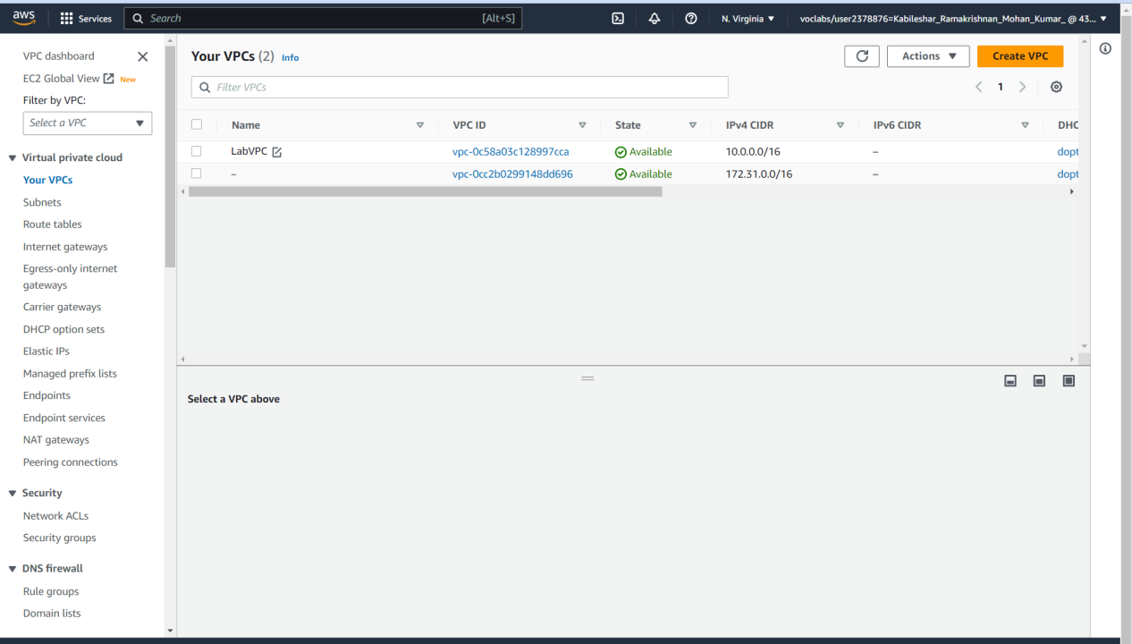  
Fig 1.1 Two VPC’s is observed one is default VPC’s which has CIDR range of 172.31.0.0/16. Other is LabVPC and has a CIDR range of 10.0.0.0/16. LabVPC is used here.

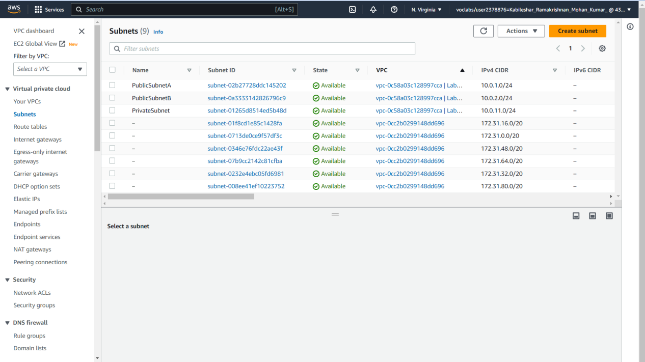  
Fig 1.2 Three subnets PrivateSubnet,PublicSubnetA, PublicSubnetB is displayed under Subnets  
  
  
  
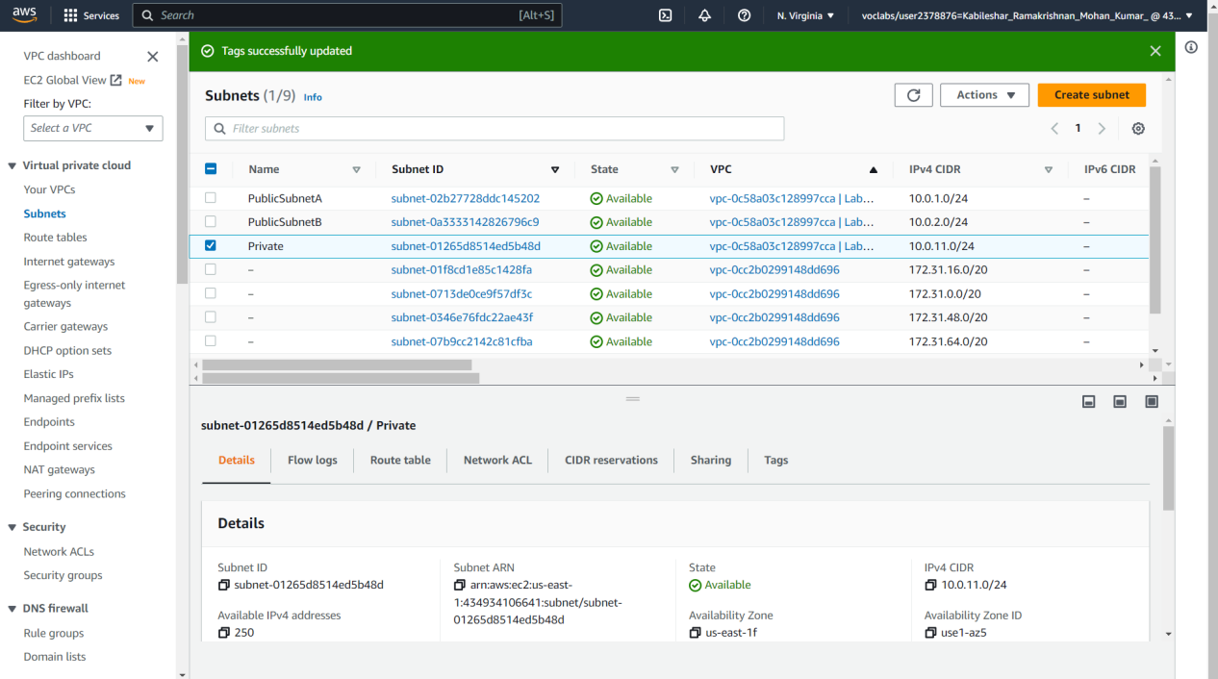  
Fig 1.3 Route tabe name is changed from changeme to Private  
  
  
  
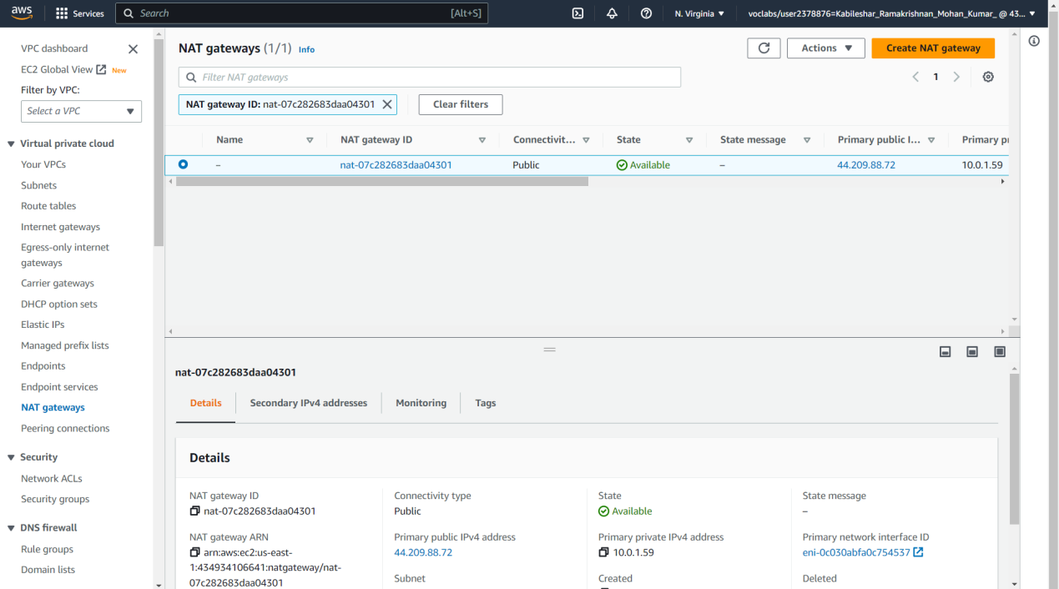  
Fig 1.4 Selected nat-xxxxxx link,under the routes tab which is target for non-local traffic. Under the details tab it is noticed that this NAT gateway runs in PublicSubnetA. Therefore, any internet-bound traffic initiated from instances in the PrivateSubnet will be routed to a NAT gateway in PublicSubnetA.  
  
  
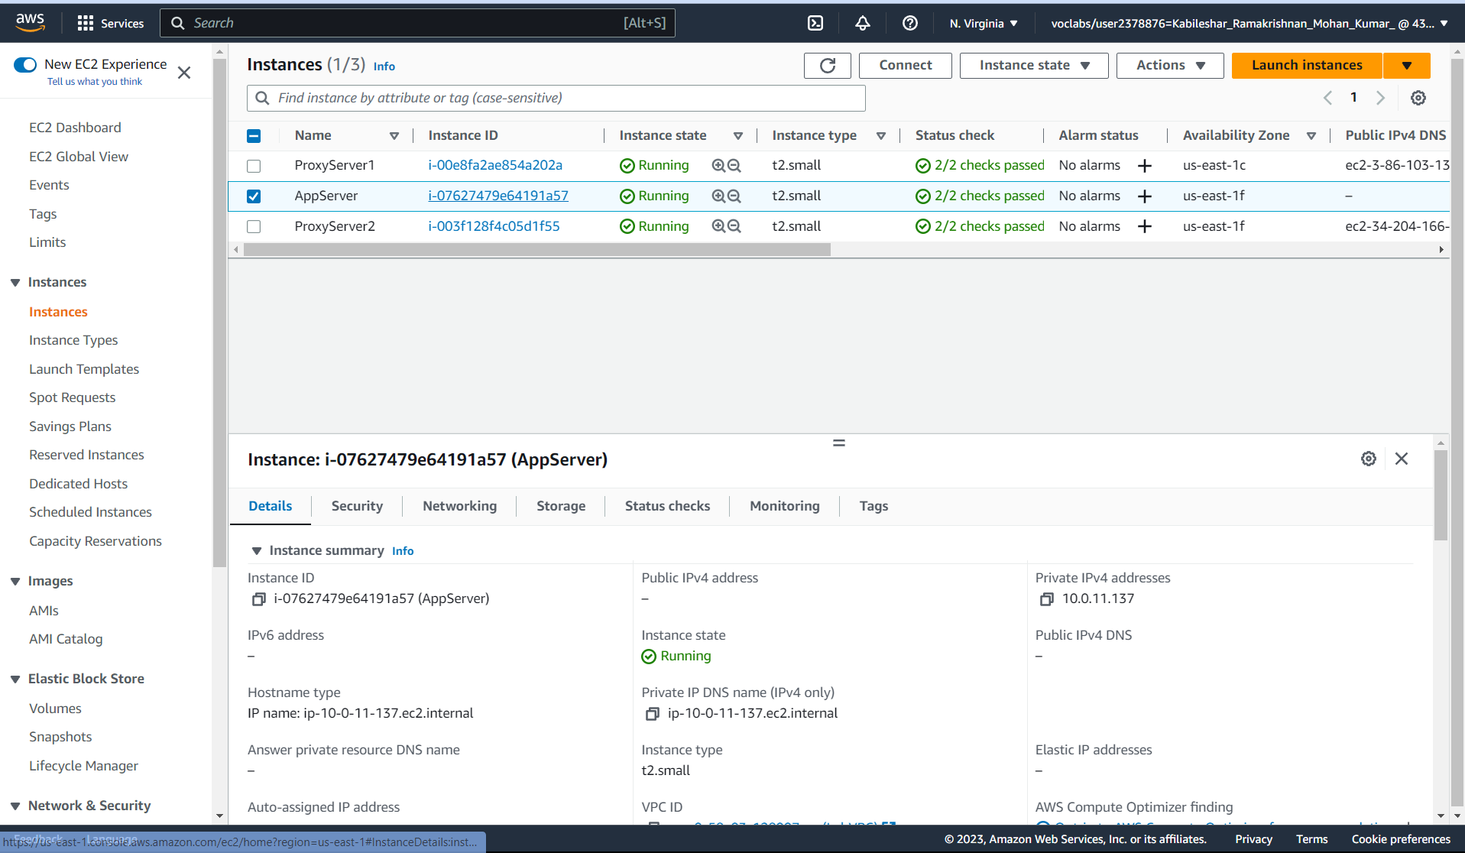  
Fig 1.5 AppServer is selected and on the details tab it is noticed instance is running in the PrivateSubnet. Also noticed that it has a private IPv4 address, but it does not have a public IPv4 address.

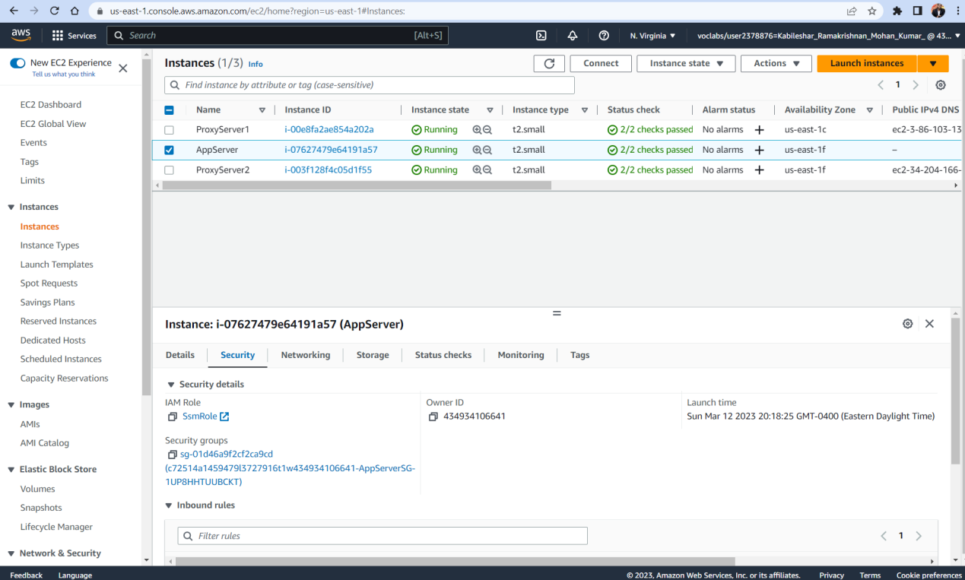  
Fig 1.6 Selected the Security tab, and then selected the link of the security group that is associated with this instance. The security group name contains AppServerSG.  
  
  
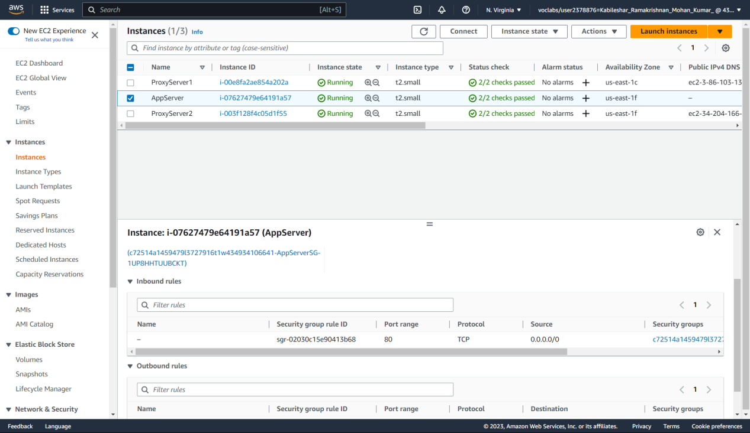  
Fig1.7 Selected the Inbound rules tab, and notice that a rule has been defined. HTTP traffic over TCP port 80 with a source of 0.0.0.0/0 (anywhere) is allowed.

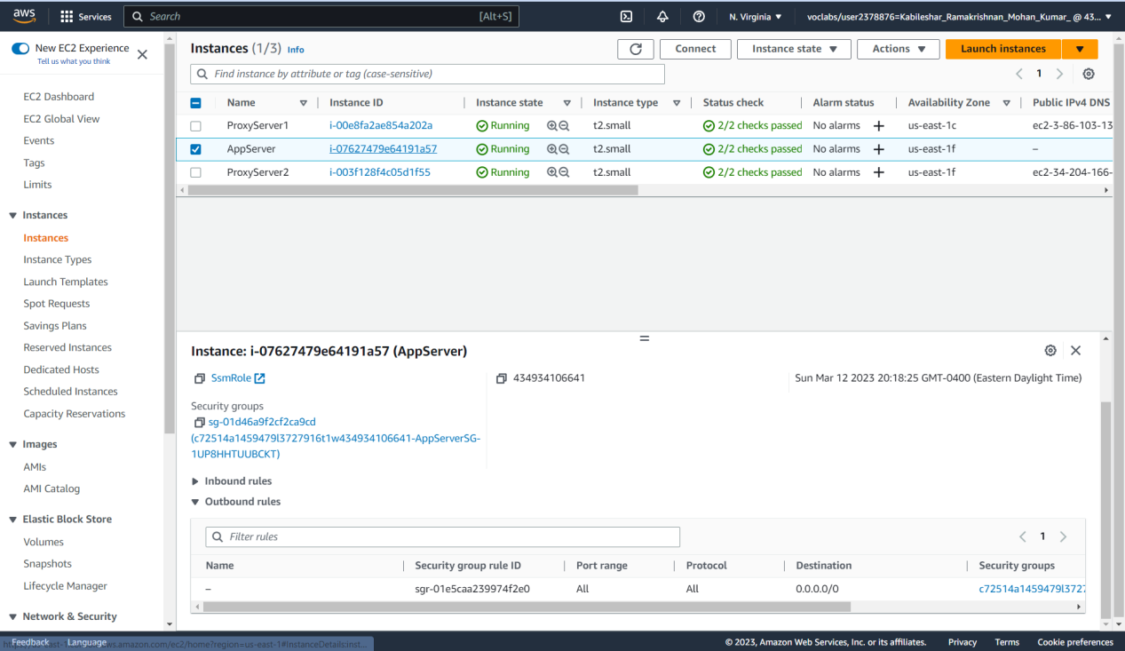  
Fig1.8 Selected the Outbound rules tab and Noticed that all outbound traffic is allowed. This is the default setting for security groups.  
  
  
Reflection  
  
After reading the task instructions, I learned how to access and analyze the network settings of LabVPC through the AWS Management Console. The LabVPC is made up of three subnets, namely PrivateSubnet, PublicSubnetA, and PublicSubnetB, with each having its own unique CIDR range. Additionally, I discovered how to change the name of a route table, and that all IP addresses within the LabVPC CIDR range are routed to local targets within the VPC, whereas all other traffic is directed to a NAT gateway.Furthermore, I was introduced to the AppServer EC2 instance, located in the PrivateSubnet and assigned a private IPv4 address without a public IPv4 address. I also analyzed the security group associated with this instance and observed that it allows incoming traffic on TCP port 80 from any source with 0.0.0.0/0.

In summary, this task provided me with knowledge of LabVPC's network settings and helped me understand how VPCs operate in AWS. It also gave me insights into security groups and how they can be used to manage inbound and outbound traffic to EC2 instances.

Part 2- Analyzing the public subnet resource settings  
  
Description  
  
This part of the lab will analyze the networking, routing, and security settings in the public subnets of the VPC.  
  
  
Preparation

* Successfully signed in AWS Management Console.

Observation

* Selected PublicSubnetA from the subnets under the navigation pane.
* Selected the route table tab and it is noticed that this public subnet route table routes 0.0.0.0/0 traffic to an internet gateway.
* Selected the igw-xxxxx link, which is the target for non-local traffic. And On the Details tab, it is noticed that this internet gateway is associated with the LabVPC.
* In the navigation pane, Instances is selected . ProxyServer1 instance is selected, and then selected the Details tab. It is noticed that, unlike the AppServer instance that runs in a private subnet, this server runs in a public subnet and has a public IPv4 address.
* The Security tab is selected.It is noticed that a security group with ProxySG in its name is associated with this EC2 instance. Under Inbound rules section, the security group allowed inbound traffic on TCP port 80 from the source.
* The ProxyServer2 instance is selected. It is Notice that this server runs in PublicSubnetB and has a public IPv4 address.
* The Security tab is selected. Also it is noticed that a security group with ProxySG2 in its name is associated with this EC2 instance.
* The link for the ProxySG2 security group is selected.
* The Inbound rules tab is choose, and then Edit inbound rules is selected.
* Add rule is selected and configured as follows:  
  Type: Choose HTTP.  
  Source: Choose Anywhere-IPv4

Screenshots

## Screenshot 2023-03-12 204804 Fig 2.1 Selected PublicSubnetA from the subnets under the navigation pane.

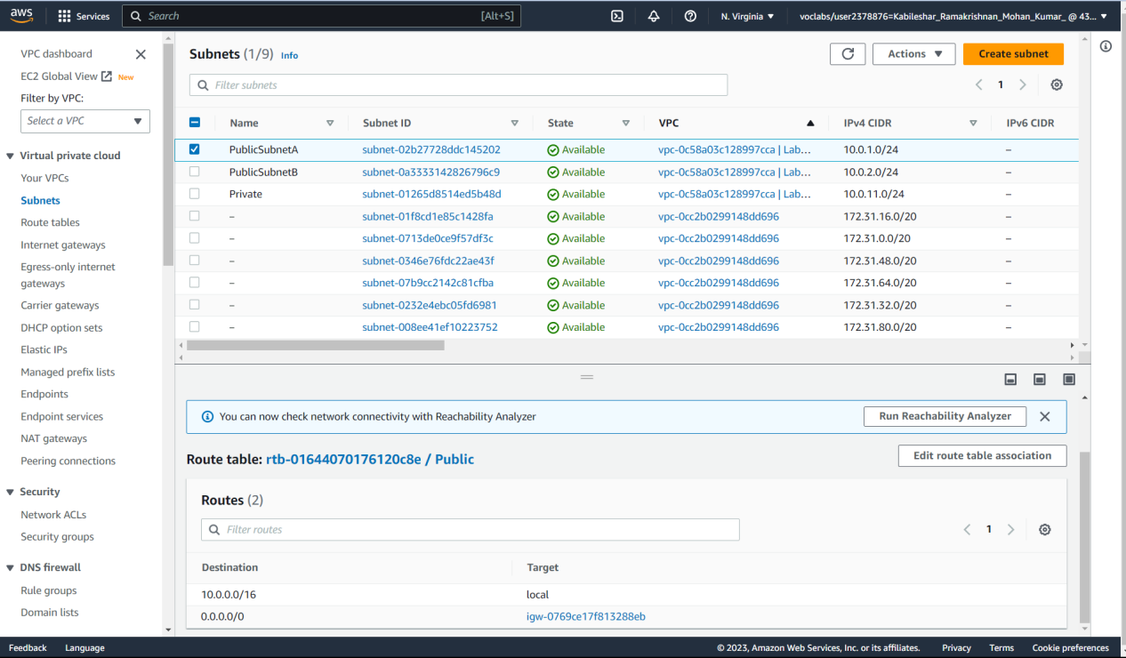  
Fig 2.2 Selected the route table tab and it is noticed that this public subnet route table routes 0.0.0.0/0 traffic to an internet gateway.

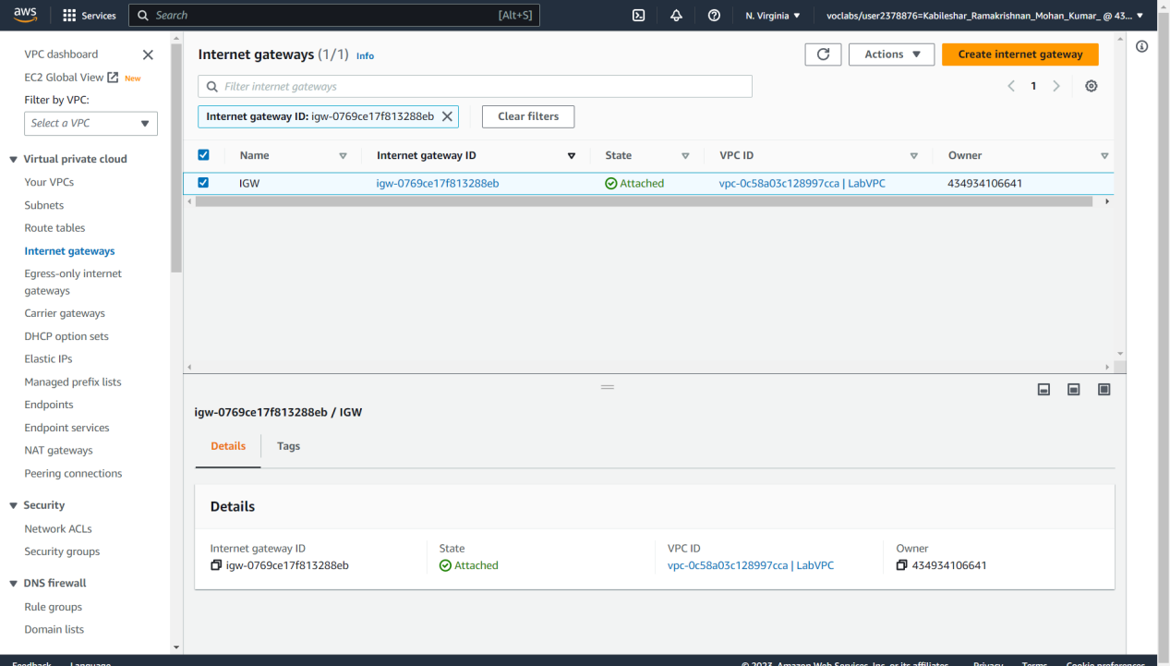  
Fig 2.3 Selected the igw-xxxxx link, which is the target for non-local traffic. And On the Details tab, it is noticed that this internet gateway is associated with the LabVPC  
  
  
  
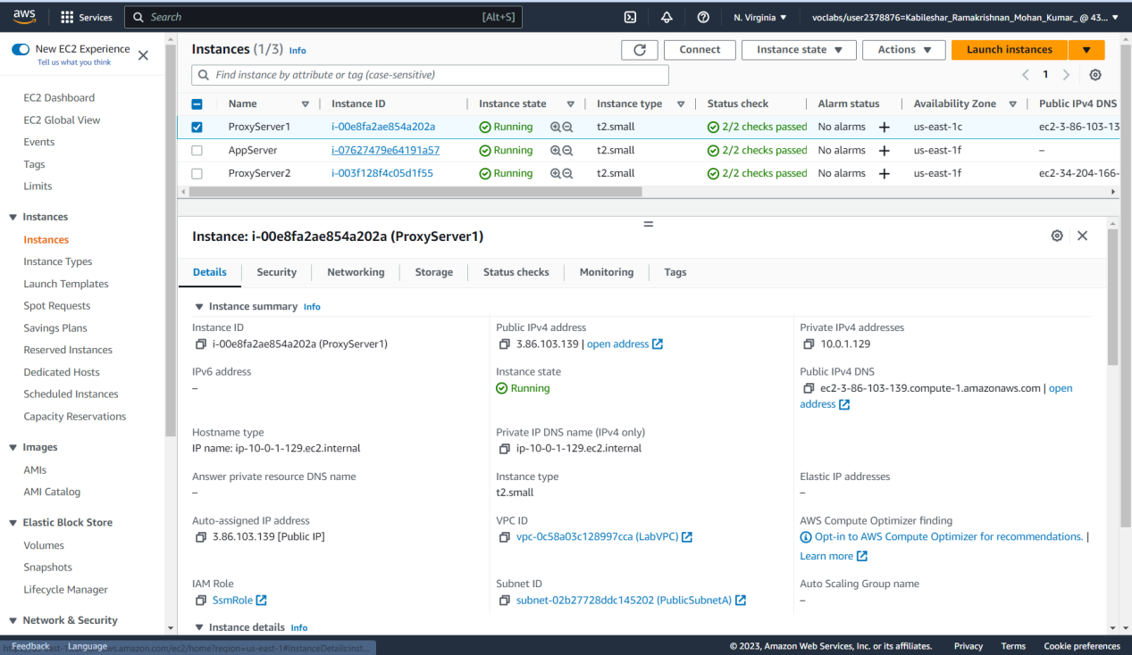  
Fig 2.4 In the navigation pane, Instances is selected . ProxyServer1 instance is selected, and then selected the Details tab. It is noticed that, unlike the AppServer instance that runs in a private subnet, this server runs in a public subnet and has a public IPv4 address.  
  
  
  
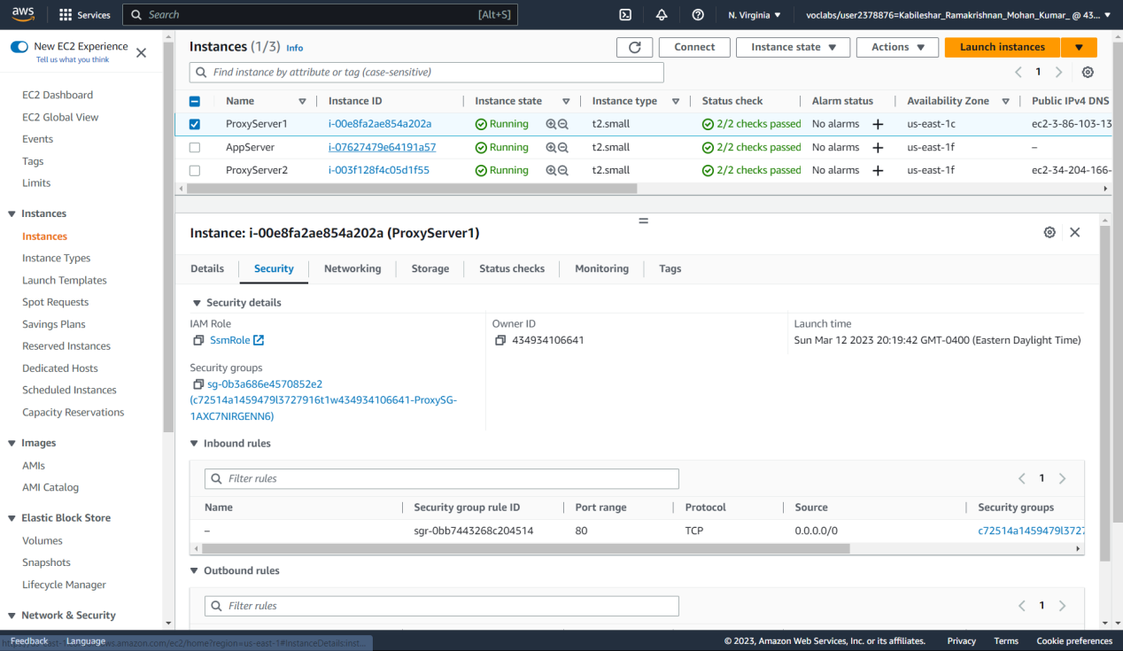  
Fig 2.5 The Security tab is selected.It is noticed that a security group with ProxySG in its name is associated with this EC2 instance. Under Inbound rules section, the security group allowed inbound traffic on TCP port 80 from the source.  
  
  
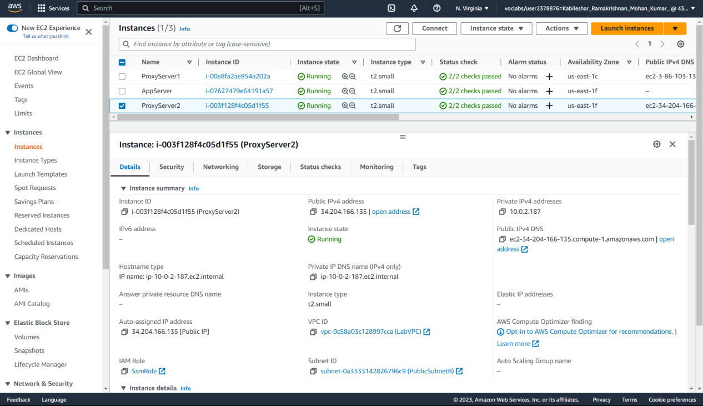  
Fig 2.6 The ProxyServer2 instance is selected. It is Notice that this server runs in PublicSubnetB and has a public IPv4 address.

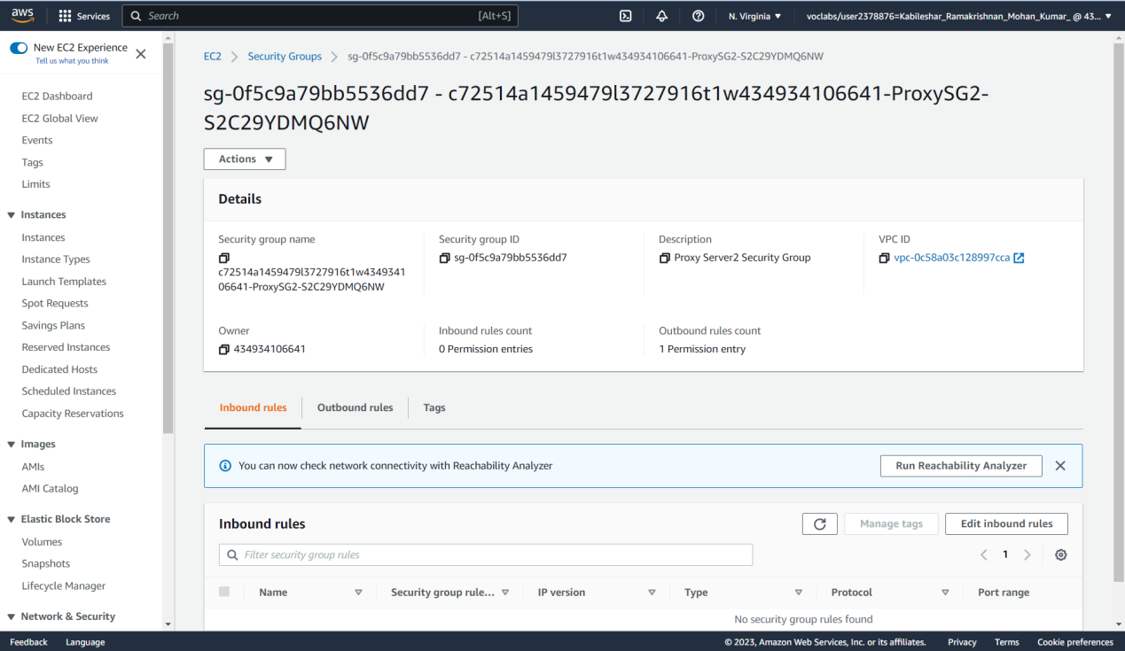  
Fig2.7 The link for ProxySG2 is selected  
  
  
  
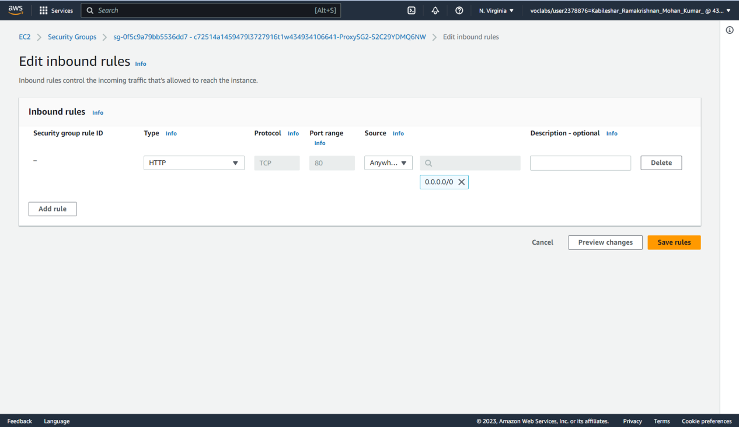  
Fig 2.8 Configuring Inbound Rule

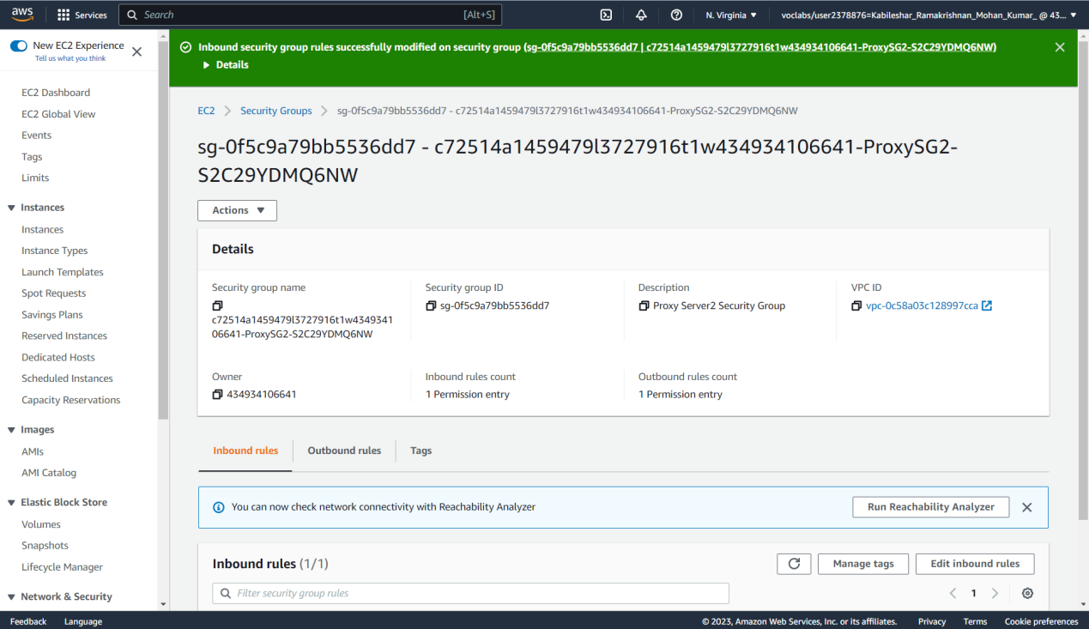  
Fig 2.9 Inbound rule is configured successfully  
  
  
  
Reflection  
  
In order to complete this assignment, I must examine the networking, routing, and security configurations in the VPC's public subnets. The instructions show how to view information about the ProxyServer1 and ProxyServer2 instances running in PublicSubnetA and PublicSubnetB, respectively, and their associated security groups, as well as how to access and analyse routing details that affect EC2 instances in PublicSubnetA. Also, it is told to update the ProxySG2 security group's inbound rules. This task teaches how to configure security groups for various access behaviours depending on the network connection and how VPCs operate in Amazon. I can easily follow along and develop a better understanding of the AWS console thanks to the clear explanations and screenshots.

Part 3- Testing HTTP connectivity from public EC2 instances  
  
Description  
  
This part of the lab will allow us to connect to the different instances that have been provisioned as part of lab environment  
  
  
Preparation

* Successfully signed in AWS Management Console.

Observation

* Selected ProxyServer1 instances from the instances under the navigation pane.
* Under the Details tab below, the Public IPv4 address is copied , and paste it in a new browser tab.
* It is noticed that I am able to access it because ProxyServer1 is configured to forward all TCP port 80 traffic to the AppServer, and both the ProxySG security group and the AppServerSG security group are configured to allow the inbound traffic.
* Under the Details tab below, the Public IPv4 address is copied , and paste it in a new browser tab.
* It is noticed that I am able to access it because ProxyServer2 is configured to forward all TCP port 80 traffic to the AppServer, and both the ProxySG security group and the AppServerSG security group are configured to allow the inbound traffic.

Screenshots  
  
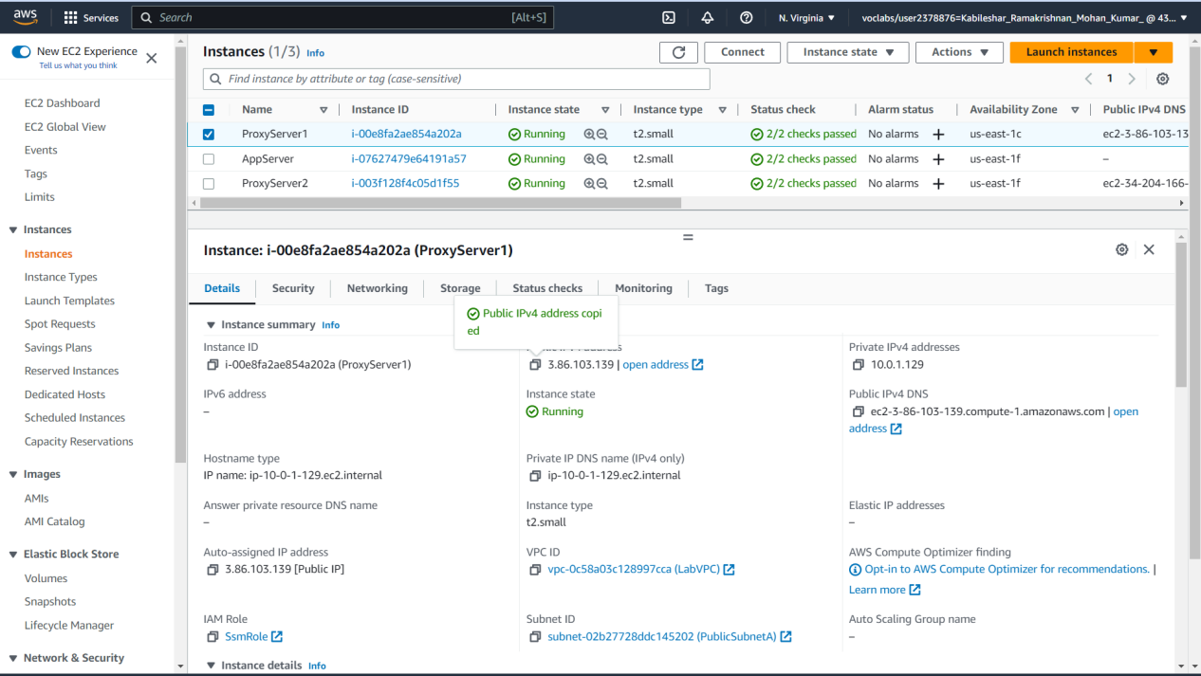Fig 3.1Under the Details tab below, the Public IPv4 address is copied , and paste it in a new browser tab.  
  
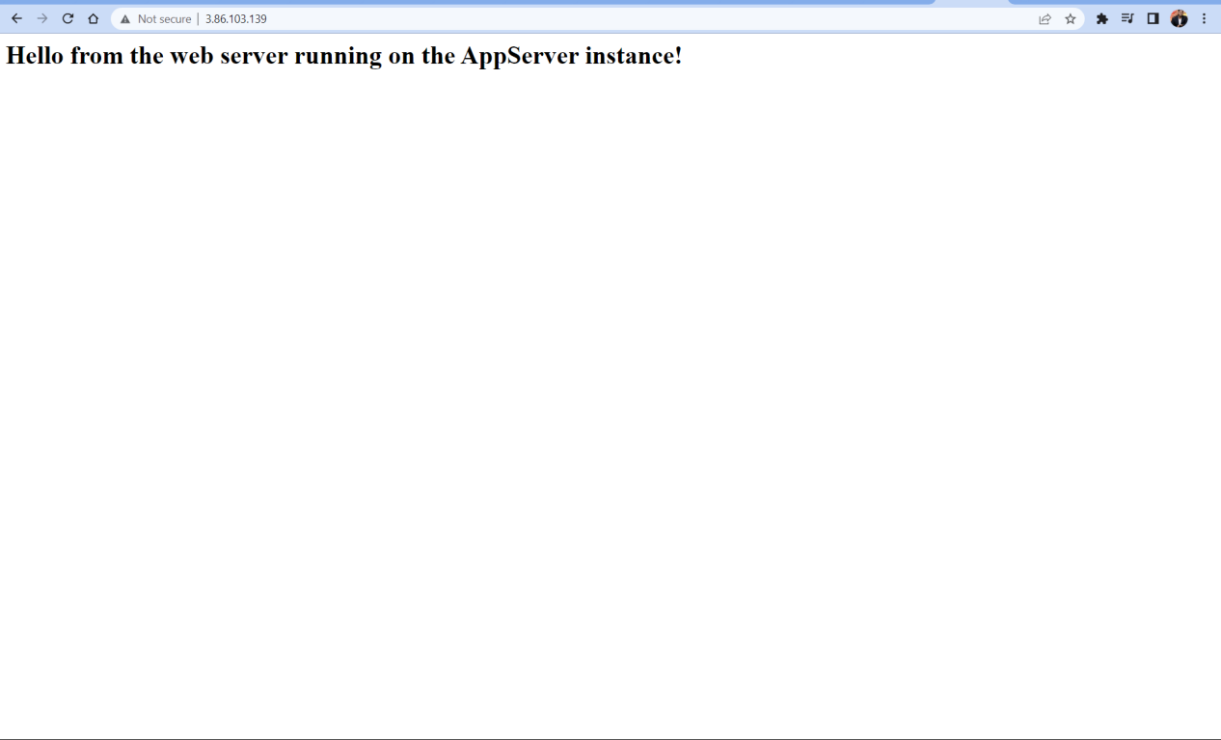  
Fig 3.2 I am able to Successfully access the ProxyServer1

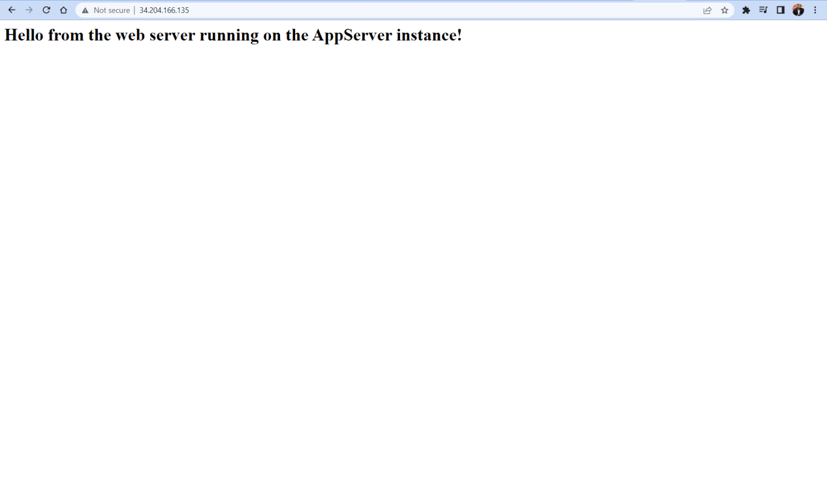  
Fig 3.3 I am able to Successfully access the ProxyServer2  
  
  
Reflection  
  
In this task, I will establish connections to the different instances available in this lab environment. At present, all three security groups permit connections over TCP port 80 from all traffic sources. The proxy servers are located in public subnets, which can be accessed from the internet. On the other hand, the application server is located in a private subnet and can only be accessed by servers located inside the VPC, either in a public or private subnet. To access the web server on the AppServer instance, I need to first connect to one of the proxy servers since they are configured to forward TCP traffic on port 80 to the AppServer.To test the loading of a web page hosted on the AppServer, I need to access the ProxyServer1 public IP address. This is done by navigating to the Instances option in the Amazon EC2 console and selecting the ProxyServer1 instance. On the Details tab, copy the Public IPv4 address, and paste it in a new browser tab. The website that loads is hosted on the application server, and I can access it because ProxyServer1 is configured to forward all TCP port 80 traffic to the AppServer, and both the ProxySG security group and the AppServerSG security group allow inbound traffic.I can use the same approach to test loading a webpage by accessing the ProxyServer2 public IPv4 address. The website that loads is the same as of ProxyServer1. This indicates that both ProxyServer1 and ProxyServer2 have access to the web server that runs on the AppServer instance.

Part 4- Restricting HTTP access by using an IP address  
  
Description  
  
This part of the lab will allow us to update the AppServerSG security group to only allow access from a single internal IP address  
  
Preparation

* Successfully signed in AWS Management Console.

Observation

* ProxyServer1PrivateIP address is copied to the clipboard from the AWS details link
* Security group is selected from the navigation pane. It is noticed that i can access security groups from both the Amazon VPC and Amazon EC2 consoles.
* AppServerSG is selected from the security group
* Inbound rules is edited using Edit inbound Rule.
* HTTP rules are modified as follows:  
  In the source field 0.0.0.0/x is deleted. Following that ProxyServer1PrivateIP is pasted in the source field.At the end /32 is added at the end of the IP
* ProxyServer1PublicIP is copied from the AWS details link and pasted in the new browser tab. IT is noticed that I am able to access the application server from ProxyServer1.
* ProxyServer2PublicIP is copied from the AWS details link and pasted in the new browser tab. IT is noticed that I am not able to access the application server from ProxyServer2

Screenshot  
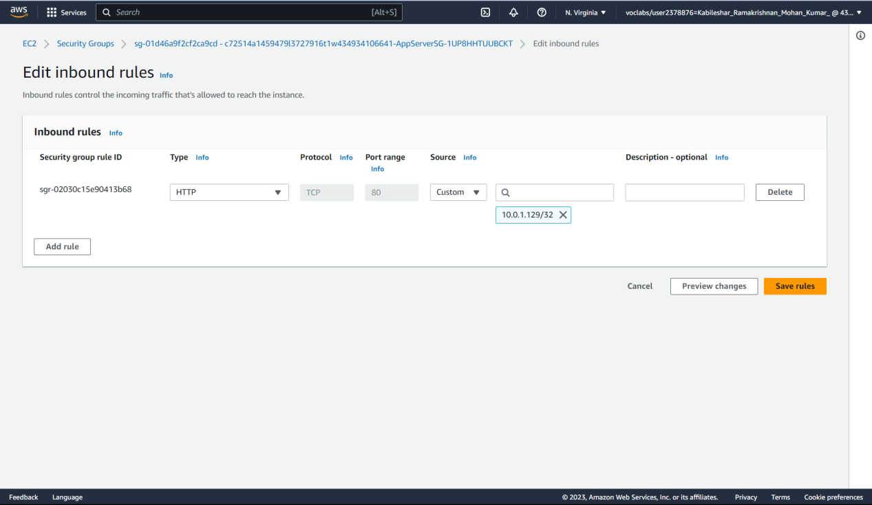  
Fig4.1 HTTP rules are modified as follows:  
In the source field 0.0.0.0/x is deleted. Following that ProxyServer1PrivateIP is pasted in the source field.At the end /32 is added at the end of the IP

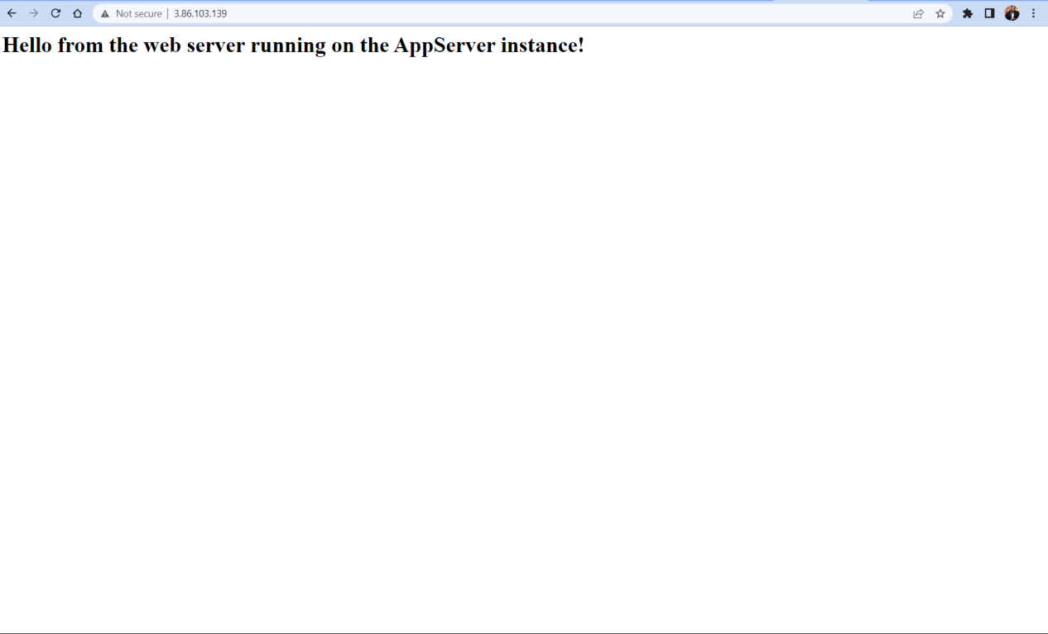  
Fig 4.2 ProxyServer1PublicIP is copied from the AWS details link and pasted in the new browser tab. IT is noticed that I am able to access the application server from ProxyServer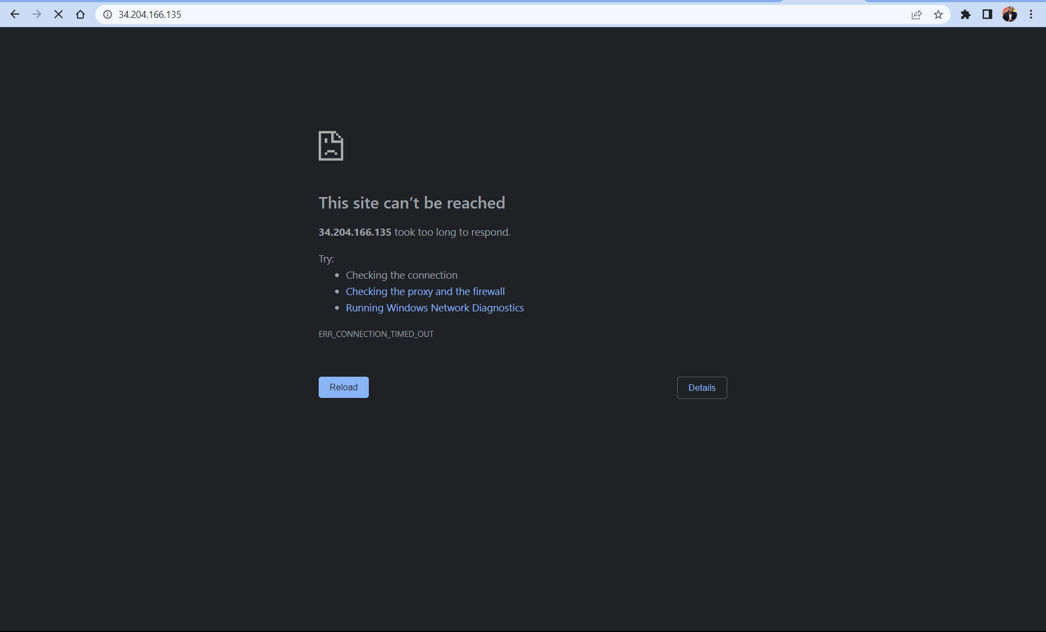  
Fig 4.3 ProxyServer2PublicIP is copied from the AWS details link and pasted in the new browser tab. IT is noticed that I am not able to access the application server from ProxyServer2  
  
  
  
  
Reflection  
  
  
This task involves restricting access to the AppServerSG security group from a single internal IP address, and testing access again. To do this, I copied the private IPv4 address of ProxyServer1, which can be found in the AWS console or accessed conveniently through the AWS Details link. After copying, the inbound rulesis edited to the AppServerSG security group and modified the HTTP rule by deleting 0.0.0.0/0 in the Source field and pasting the ProxyServer1PrivateIP value into the field, followed by adding /32 to the end of the IP address. Upon saving the rules, I will test website access again by loading the ProxyServer1 public IP address in a browser tab and then repeating the same step using the ProxyServer2 public IP address. The latter test is expected to fail since the AppServerSG security group only accepts traffic from the IP address assigned to ProxyServer1 and rejects any other source.

Part 5- Scaling restricted HTTP access by referencing a security group  
  
Description  
  
This part of the lab will allow to look at the security group assigned to the ProxyServer2 host. This means that any instance that is assigned the ProxySG security group will be granted permissions to send HTTP traffic over port 80 to the application server.  
  
  
Preparation

* Successfully signed in AWS Management Console.

Observation

* Selected the Security groups under the amazon EC2 console.
* AppServerSG group is selected.
* Inbound rules is edited using the Edit Inbound Rules and the previously created rule is deleted
* New rule is created using Add Rule and configured as follows:  
    
  Type: Choose HTTP.

Source: Choose Custom.

In the Source field, SG is typed and ProxySG is selected from the dropdown.

* New Rules have been added and saved.
* Navigated to the Instances and selected ProxyServer2.
* Navigated to the change Security groups from the Action menu on the top
* ProxySG2 group is removed and ProxySG is add to the security group.
* ProxyServer1PublicIP address is copied from the AWS details page and pasted in the new browser and Successfully the website loads.
* ProxyServer2PublicIP address is copied from the AWS details page and pasted in the new browser and Successfully the website loads.

Screenshots  
  
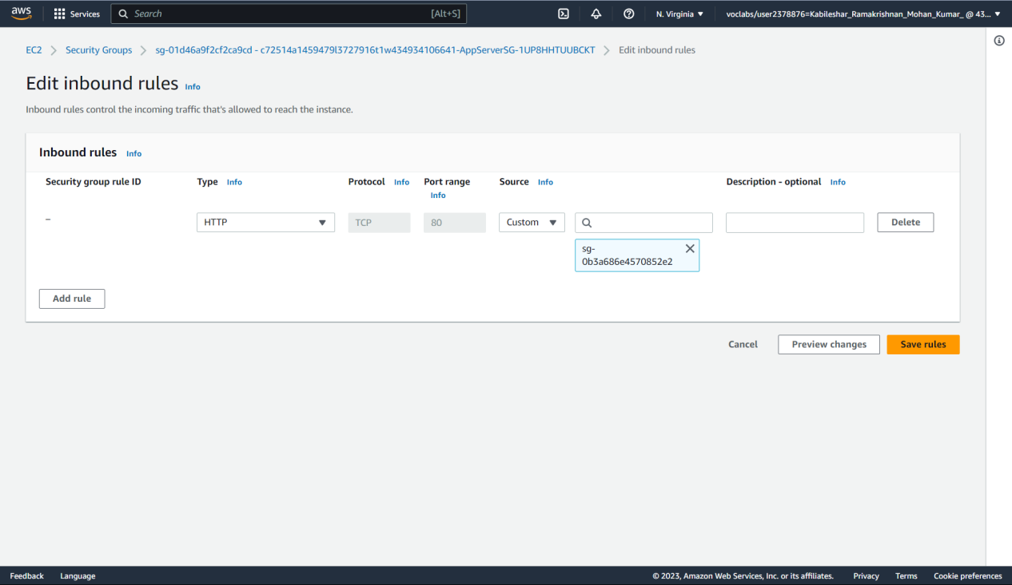  
Fig 5.1 New rule is created using Add Rule and configured and SG is selected from the dropdown ProxySG.

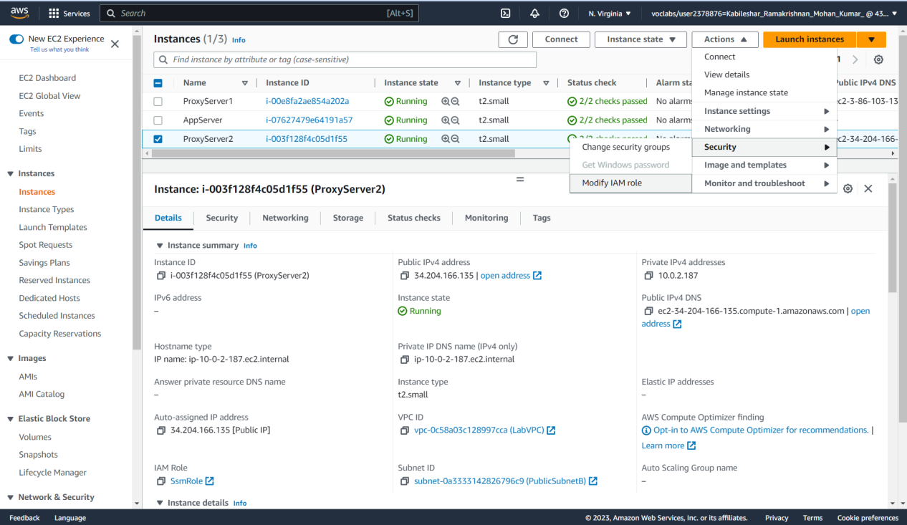  
Fig 5.2 Navigated to the change Security groups from the Action menu on the top  
  
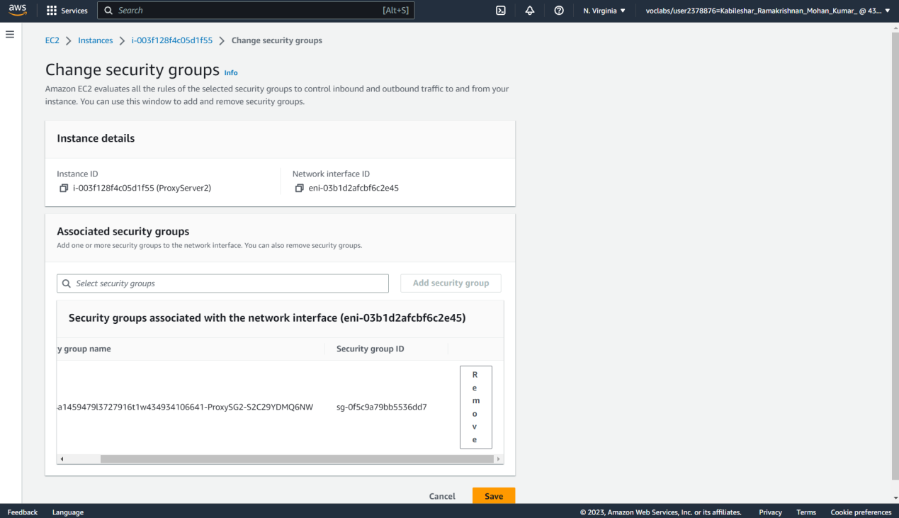  
Fig 5.3 ProxySG2 group is removed

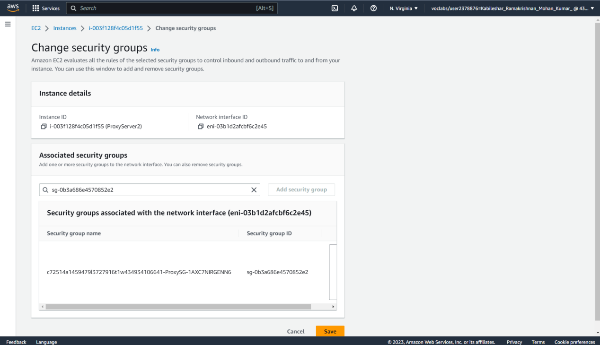  
Fig 5.4 ProxySG group is added  
  
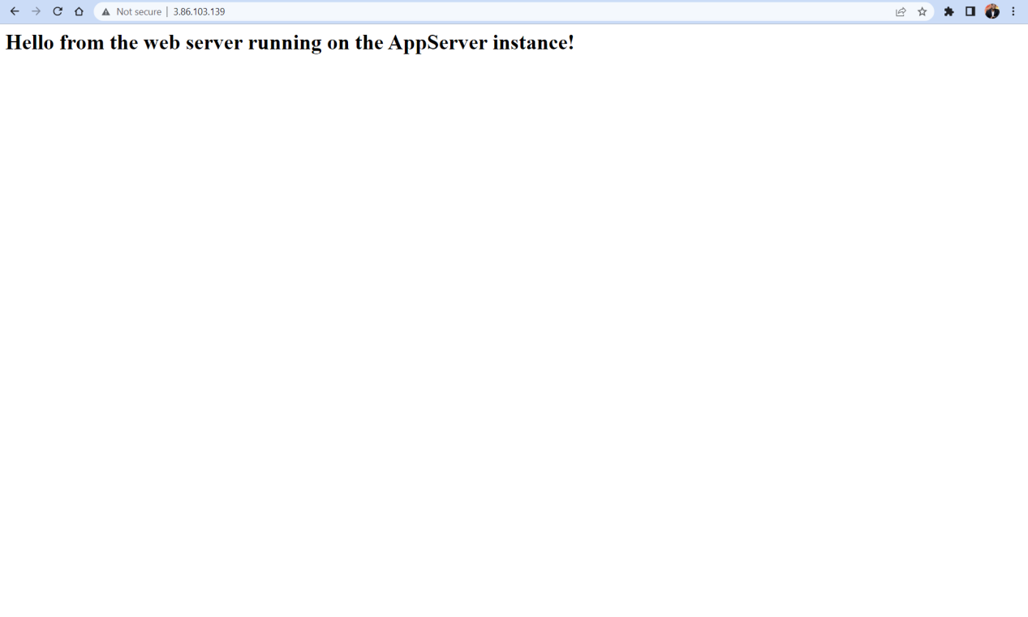  
Fig 5.5 ProxyServer1PublicIP address is copied from the AWS details page and pasted in the new browser and Successfully the website loads  
  
  
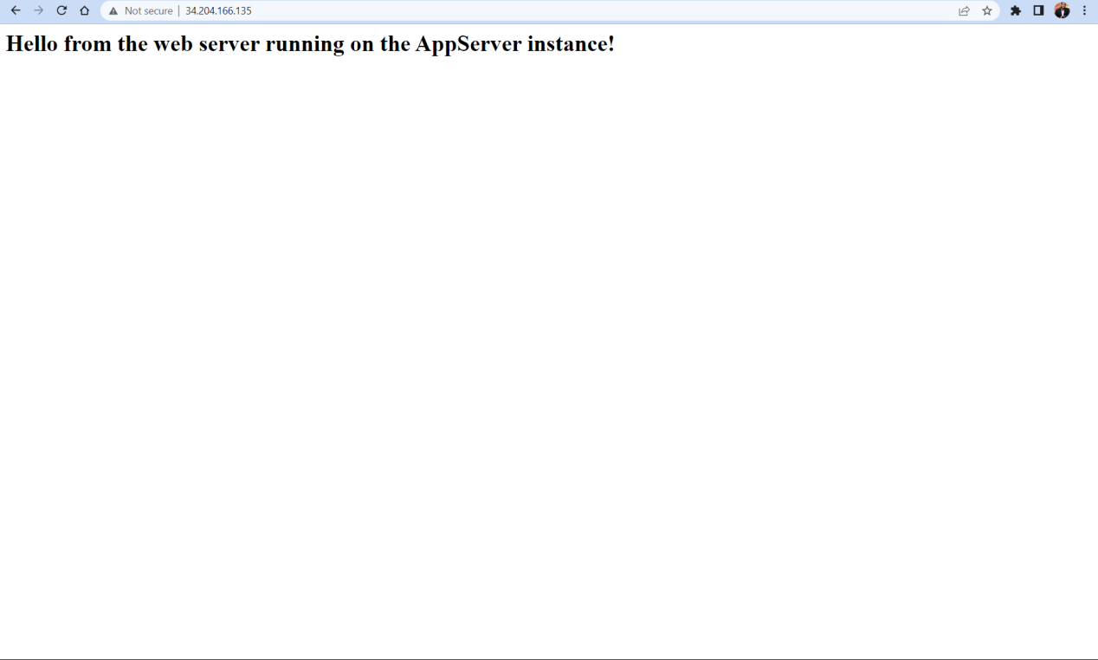  
Fig 5.6 ProxyServer2PublicIP address is copied from the AWS details page and pasted in the new browser and Successfully the website loads

Part 6- Restricting HTTP access by using a network ACL  
  
Description  
  
This part of the lab will allow to explore how to use network ACLs to control access to EC2 instances in a VPC.  
  
  
Preparation

* Successfully signed in AWS Management Console.

Observation

* NetworkACL is selected from the navigation pane.
* NetworkACL associated with labvpc is selected
* Inbound rules is edited from edit inbound rules
* New rule is added from Add new rule and configured as follows:  
    
  Rule Number: 99  
  Type: HTTP  
  Allow/Deny: Deny
* New rules is saved by clicking save changes
* ProxyServer1PublicIP address is selected and pasted in new browser tab and I observe that Connection got timed out and fails to load
* Another Network ACL rule is added and configured as follow:  
    
  Rule Number: 98  
  Type: HTTP  
  Allow/Deny: Deny
* New rules is saved by clicking save changes
* ProxyServer1PublicIP address is selected and pasted in new browser tab and I observe that website loads successfully.

Screenshots  
  
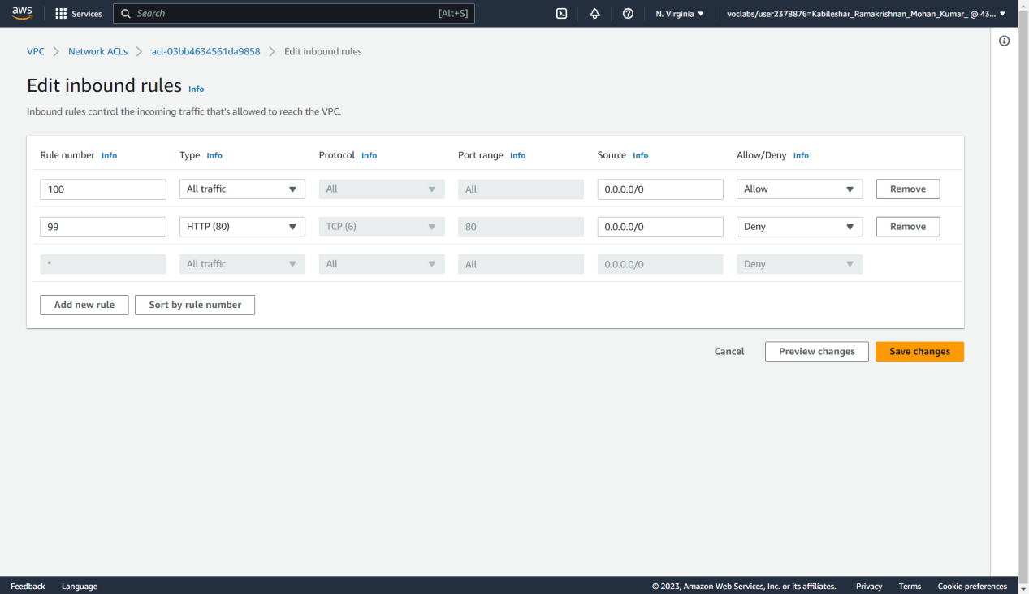  
Fig 6.1 New rule is added from Add new rule and configured   
  
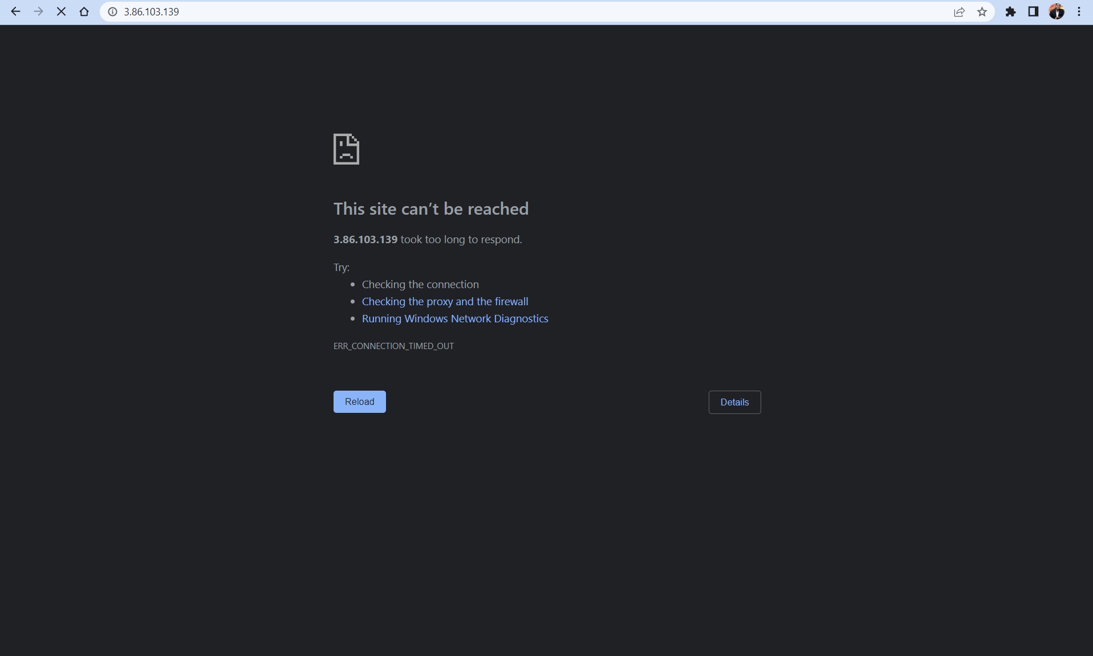  
Fig 6.2 ProxyServer1PublicIP address is selected and pasted in new browser tab and I observe that Connection got timed out and fails to load  
  
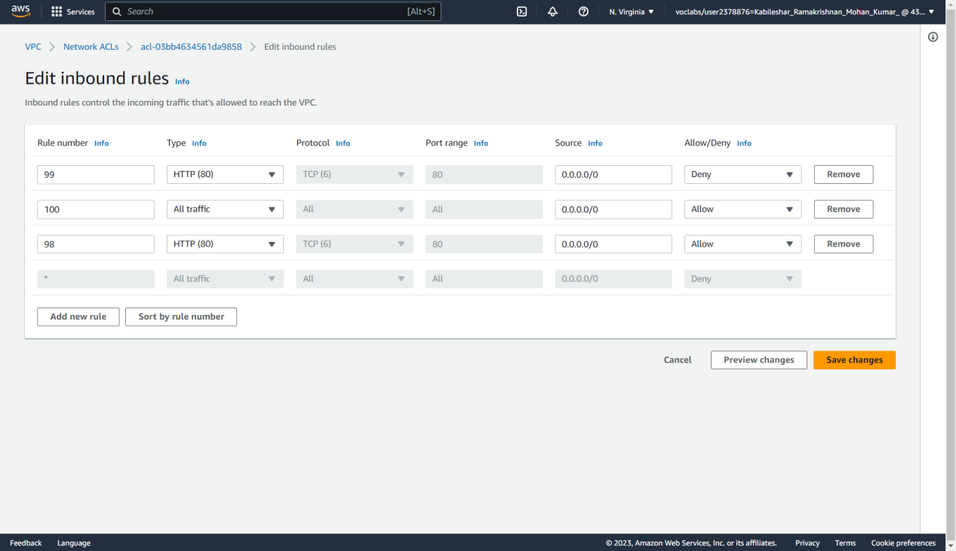  
Fig 6.3 Another Network ACL rule is added and configured  
  
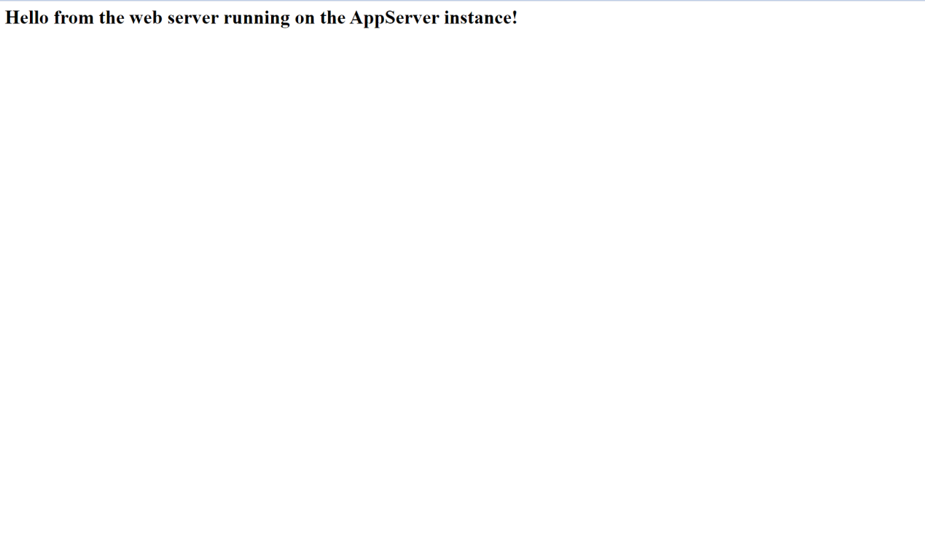  
Fig 6.5 ProxyServer1PublicIP website is loaded successfully

Reflection  
  
  
In this task, I have learned how to use network ACLs to control access to EC2 instances in a VPC. Unlike security groups, network ACLs are another way to secure access to network ports. To start, I have added a new inbound rule on the LabVPC network ACL to deny all inbound traffic on port 80. Then, I tested accessing the website from ProxyServer1, which should result in a connection timeout since the network ACL rule created blocks all connection attempts on port 80 to any EC2 instance running in the VPC. After that, another rule to the network ACL is added. The rules defined in a network ACL have a rule number, and they are evaluated in order, starting with the lowest numbered rule. When a rule matches traffic, it's applied regardless of any higher numbered rule that might contradict it. In this case, I will add an "Allow" rule for HTTP traffic on port 80. Finally, it is tested accessing the website from ProxyServer1 again, which should now load successfully.  
  
  
  
  
Part 7- Connecting to the AppServer by using a bastion host and SSH  
  
Description  
  
This part of the lab will use an SSH key to connect to a server in PublicSubnetB by using SSH over TCP port 22. Then, by using SSH port forwarding, I will then be able to connect to the AppServer, which is running in the private subnet.to explore how to use network ACLs to control access to EC2 instances in a VPC.  
  
  
Observation

* ProxyServer2 is selected as instances from the Amazon EC2 console.
* The server is renamed as Bastion and saved
* New Security group is created and configured as follow:  
    
  Security group name :BastionSG  
  Description : BastionSG  
  VPC:LabVPC is selected
* Inbound rule is created and configured as follow:  
    
  Type: SSH  
  Source: Anywhere-IPV4
* Security group is created
* Bastion instances is selected and the proxySG is removed
* BastionSG is searched and Selected as the security group
* Security group is selected and saved
* BastionPrivateIp is selected from the Aws details link
* AppserverSG is selected for the security group
* Inbound rules is edited and configured as follows :  
    
  Type: Choose SSH.  
  Source: Choose Custom.  
  BastionprivateIp is pasted and at end /32 is added
* Bastion host is connected using ssh by following commands  
    
  exec ssh-agent bash  
  ssh-add ~/.ssh/labsuser.pem
* To connect Bastion instances the following command is used  
  ssh -i ~/.ssh/labsuser.pem -A ec2-user@<BastionPublicIP>
* Appserver is connected through SSH   
  ssh ec2-user@<AppServerPrivateIP>
* File is created to prove that it is connected to the AppServer instance, run the following command.  
    
  touch newfile.txt

Screenshots  
  
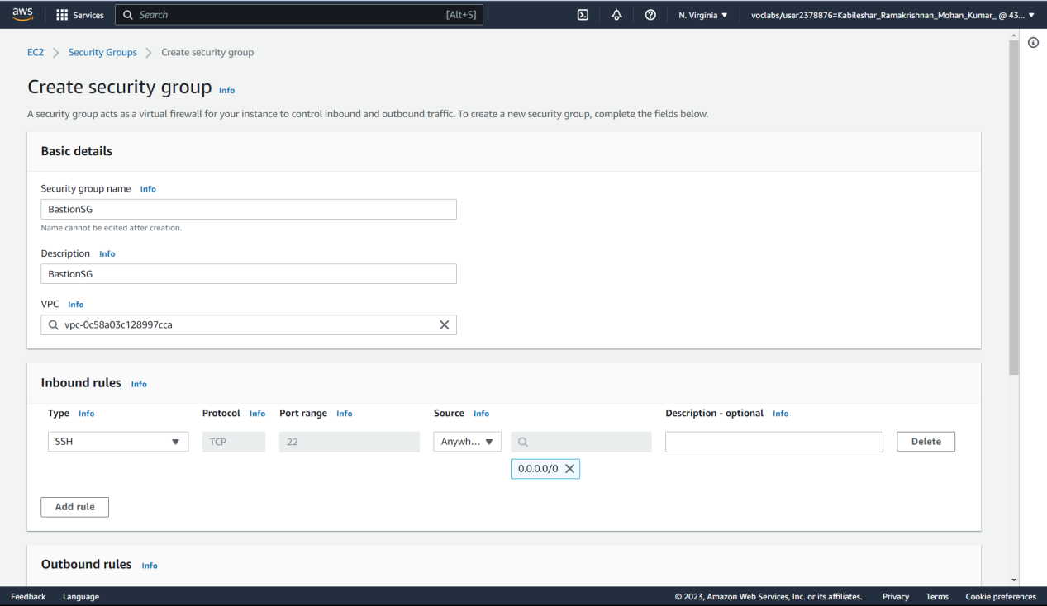  
Fig 7.1 New security group is created   
  
  
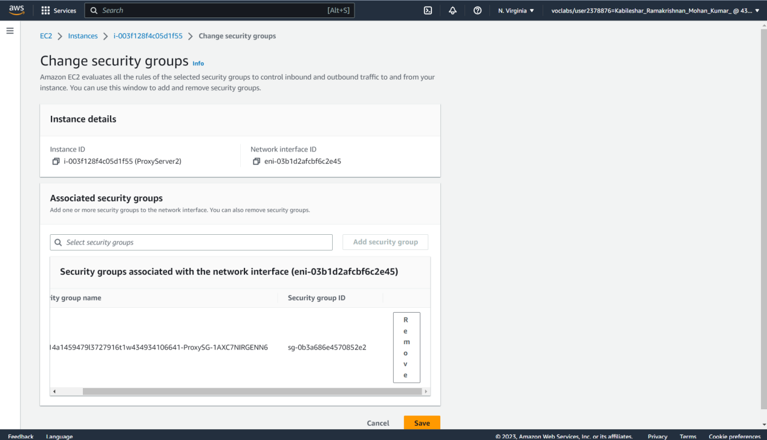  
Fig 7.2 ProxySG is removed  
  
  
  
  
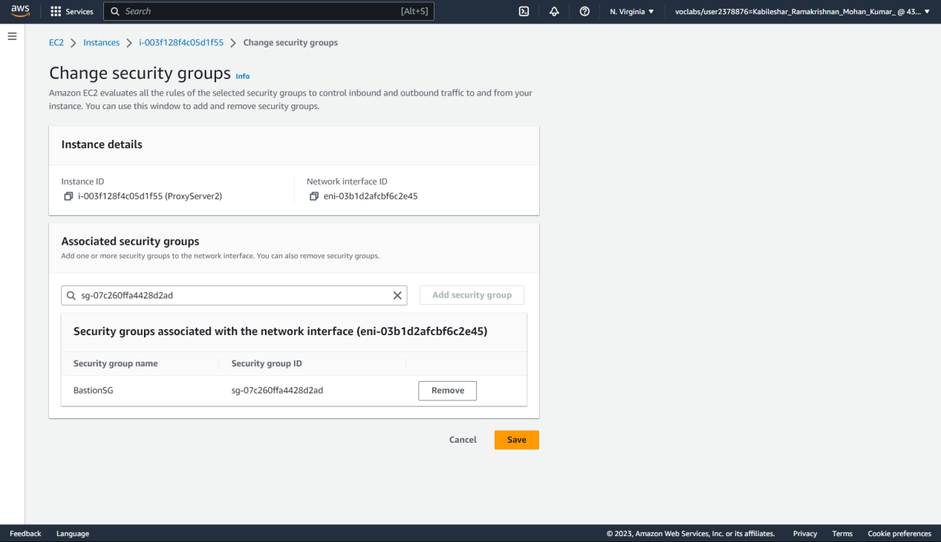  
Fig 7.3 BastionSG security group is added  
  
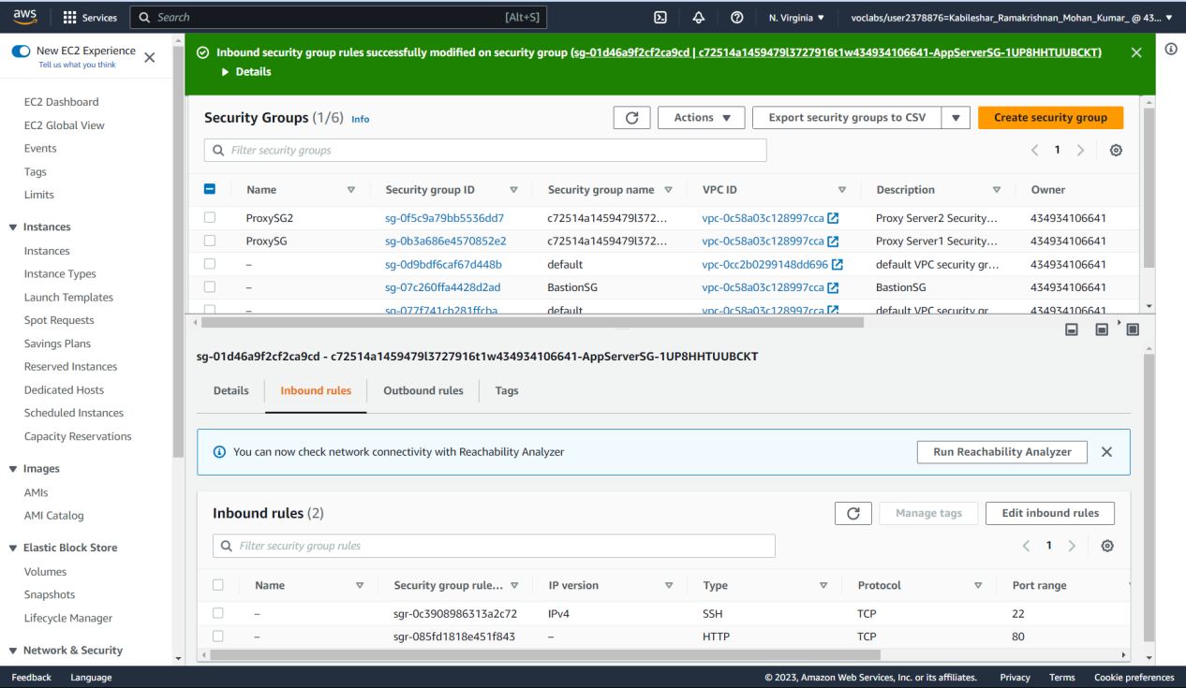  
Fig 7.4 Inbound rules is successfully modified

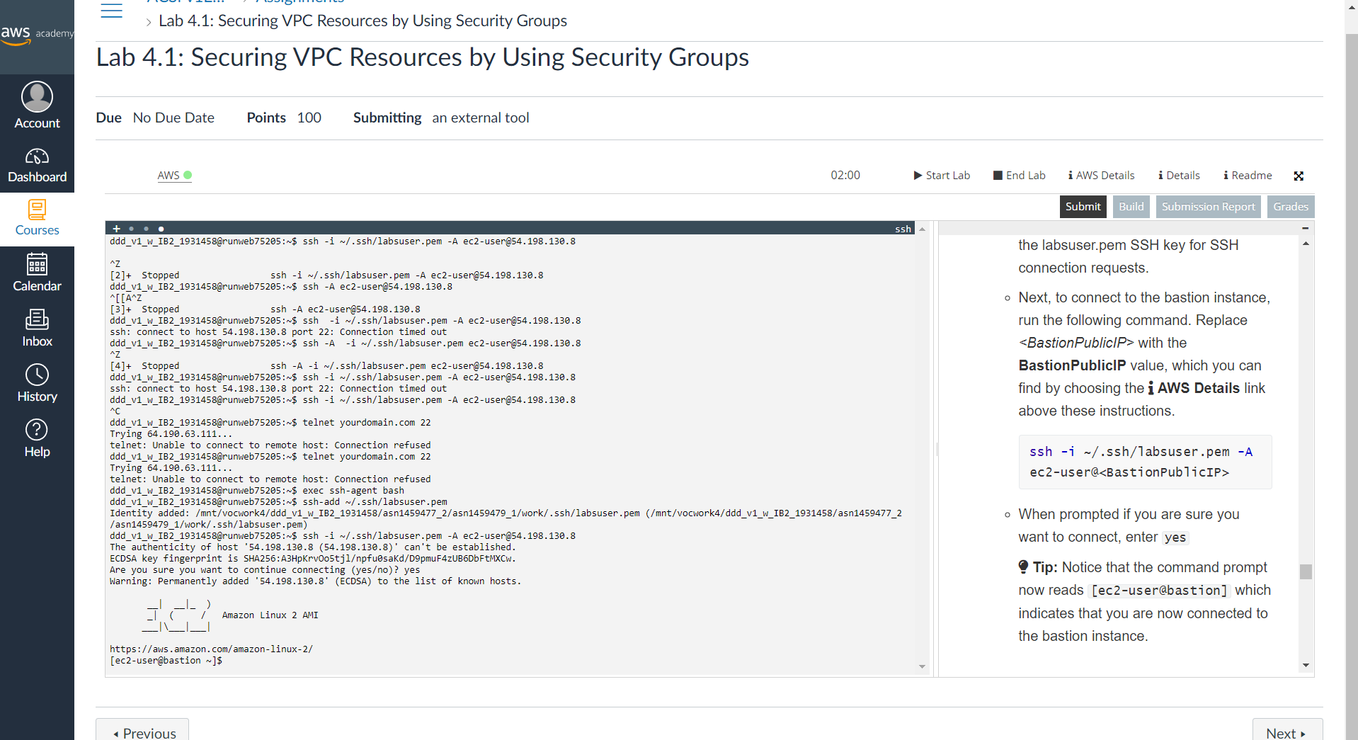  
Fig 7.5 Bastion is connected using SSH  
  
  
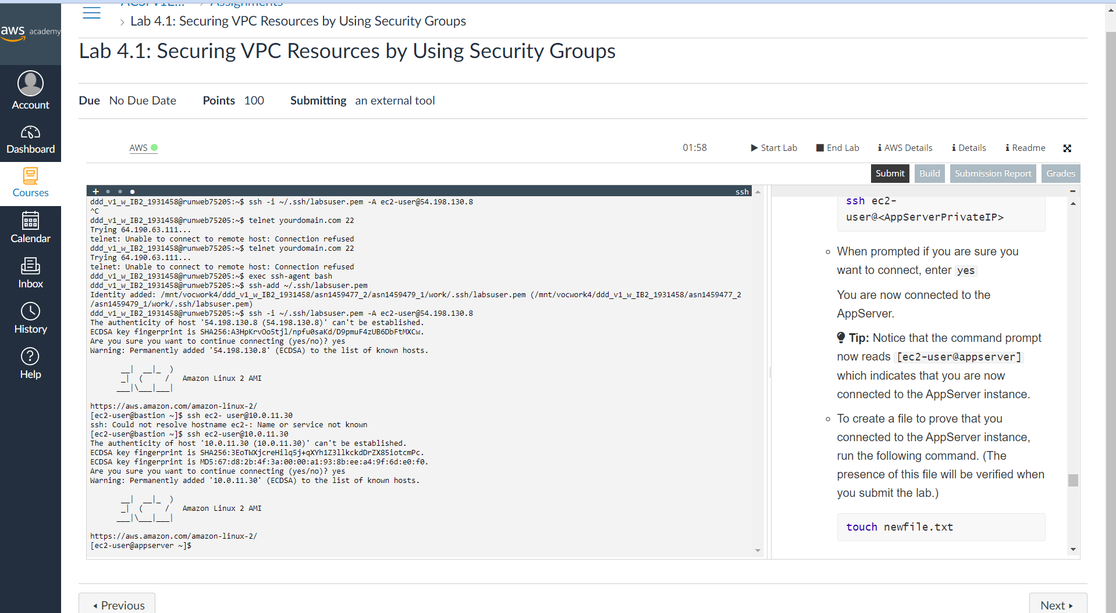  
Fig 7.6 Appserver is connected using SSH

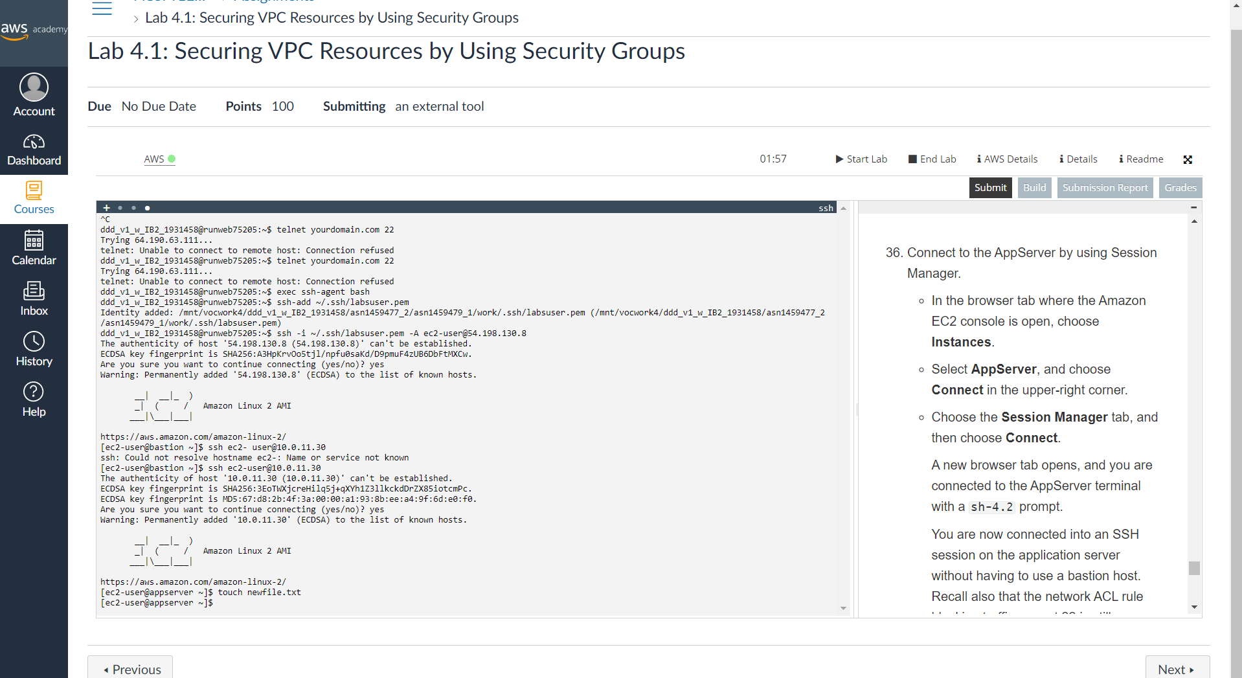  
Fig 7.7 File is created to prove that is connected to Appserver instances  
  
  
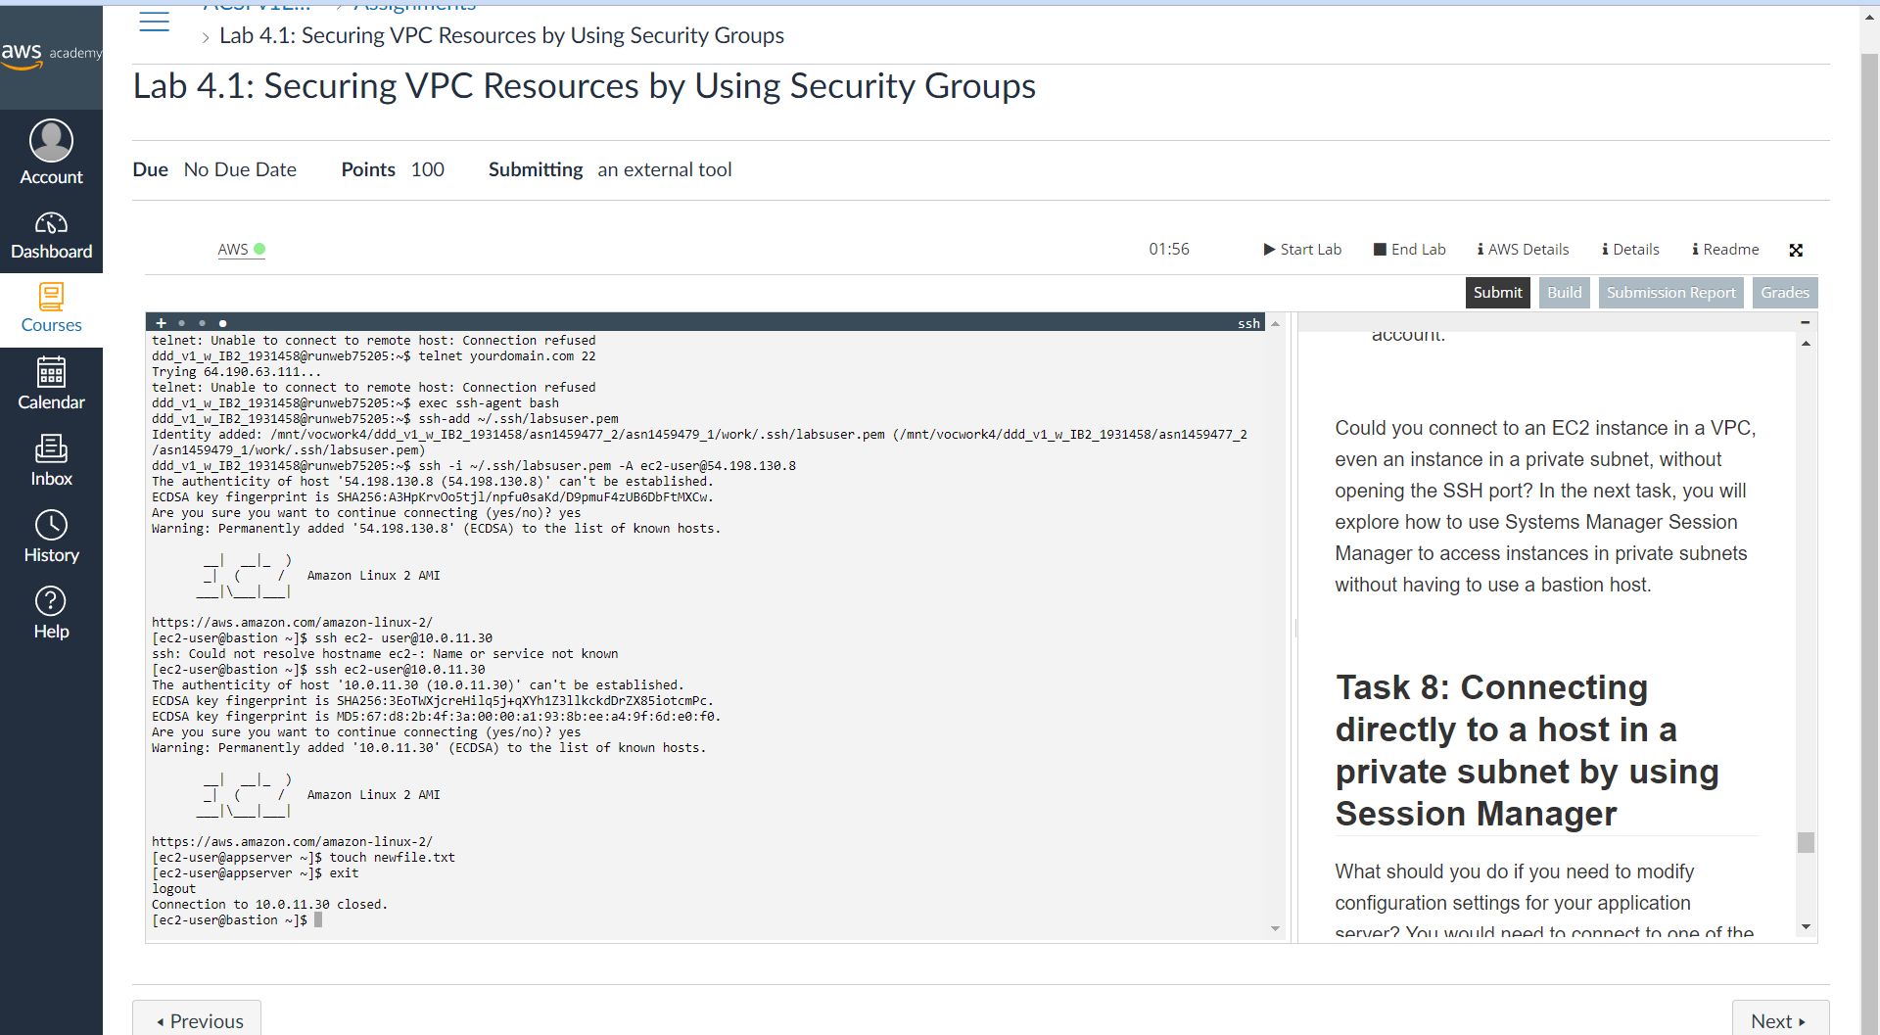  
Fig 2.8 Session is closed  
  
  
Reflection  
  
  
Through this lab I learned through the set of instructions guides the user to rename an EC2 instance and configure security groups to enable SSH connections to the instance. The instance is renamed as a bastion host, which provides access to a private network from an external network. A new security group is created for the bastion host with port 22 open. The security group of the bastion host instance is updated to use the new security group. Inbound rules for the AppServer security group are edited to allow traffic from the bastion host. The user is then able to connect to the bastion host and the AppServer using SSH. The connection to the AppServer is made through the bastion host, and a file is created to prove that the connection was successful. The instructions emphasize the importance of avoiding storing SSH keys on the bastion host.

Part 8- Connecting directly to a host in a private subnet by using Session Manager  
  
Description  
  
This part of the lab will allow us to directly connect to the application instance, which is not internet accessible  
  
  
Observation

* Selected the Connect from the Appserver is selected.
* From the Session manager tab and then Connect is selected
* Inorder to the modify the website hosted on the server the following command is typed:  
  sudo sed -i 's/instance!/instance! Session manager was used to edit this file./g' /var/www/html/index.html
* ProxyServer1PublicIP address is selected and pasted in new browser and the browser says Session manager was used to edit this file.
* Successfully connected to the instance that is located in a private subnet .

Screenshots  
  
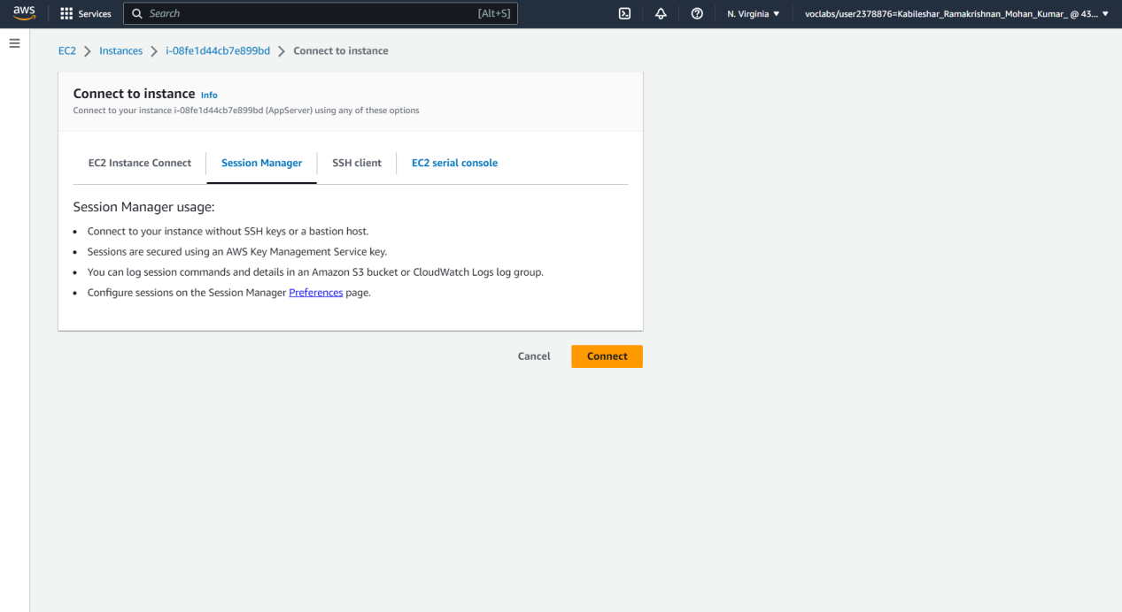  
Fig 8.1 Navigated to the session manager   
  
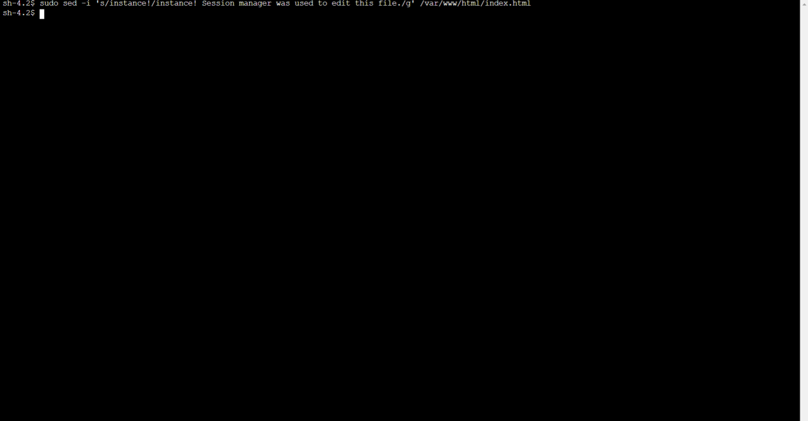  
Fig 8.2 Modify website hosted on the server  
  
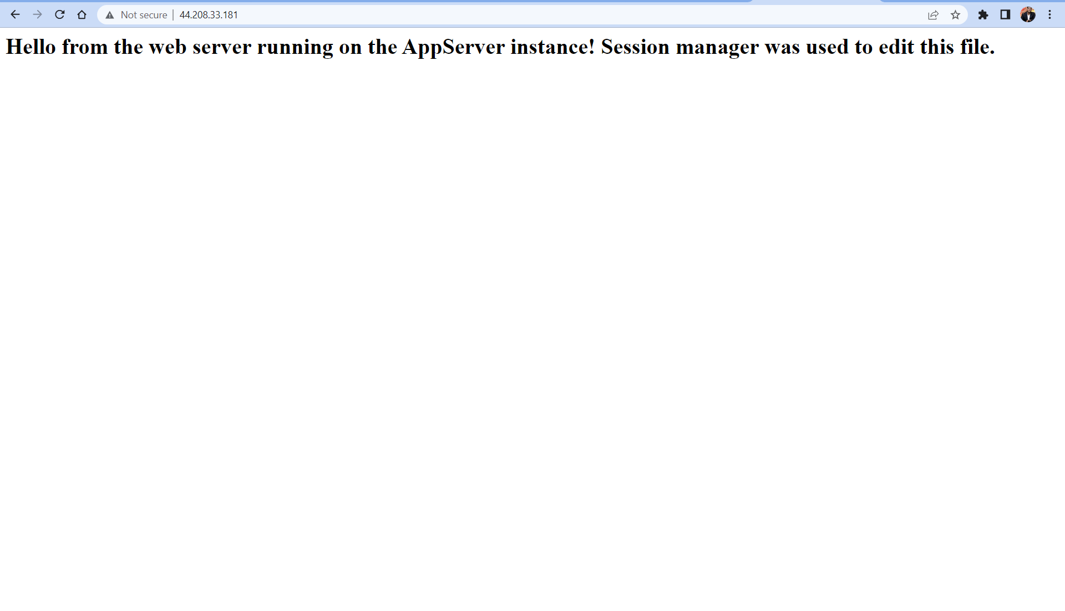Fig 8.3 Successfully connected to the instance that is located on the private subnet  
  
  
Reflection  
  
Through this task I learned that connecting to an application instance that is not accessible through the internet. The Session Manager is used to establish a direct connection to the AppServer. This eliminates the need for a bastion host. To connect to the AppServer, I selected the instance from the EC2 console and clicks the Connect button. Then, I choose the Session Manager tab and clicks Connect to establish a terminal connection. I can modify the website hosted on the server using the sudo sed command. The website can be accessed by using the ProxyServer1 public IP address. This approach offers a secure way to modify files on an instance located in a private subnet without the complexity of configuring a bastion host.

LAB 2-INFO8855 – Private Cloud Network Lab  
  
Overview

This lab provides with the opportunity to configure networking in a vSphere based private cloud environment.

Preparation

* Two ESXI host
* AD Domain server

Task 1 – Configure a VM Production Network  
  
Observation

* On each ESXi host created a port group named KRM6188-Production on a new standard virtual switch using vmnic1 for uplink on each ESXi host

Screenshots  
  
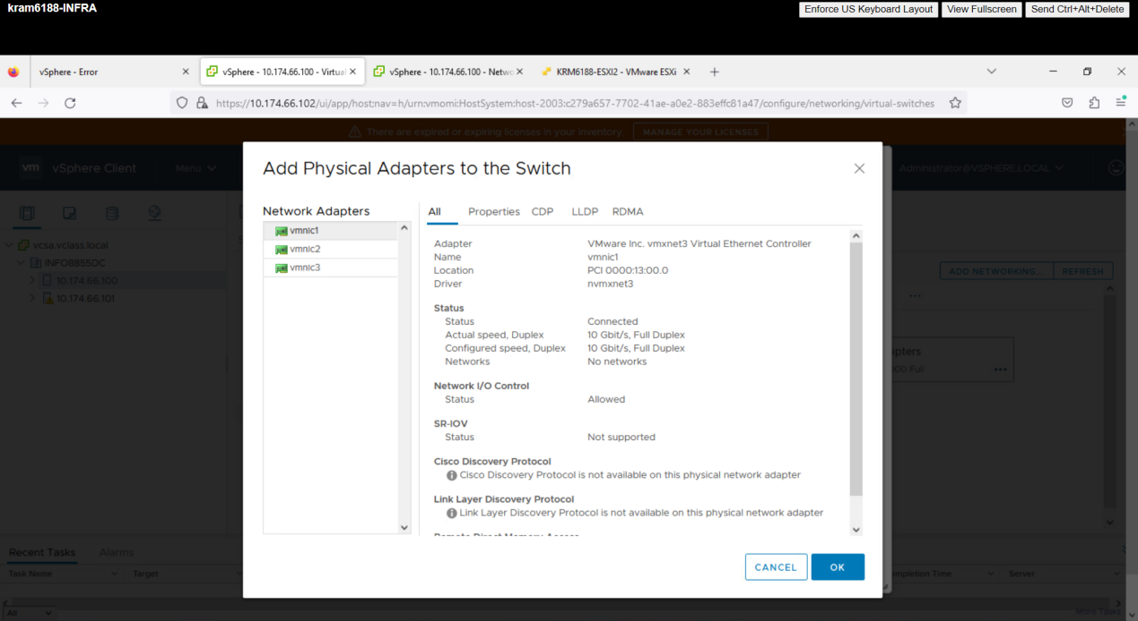  
Fig 1.1 Added the network adapters to the switch vmnic1  
  
  
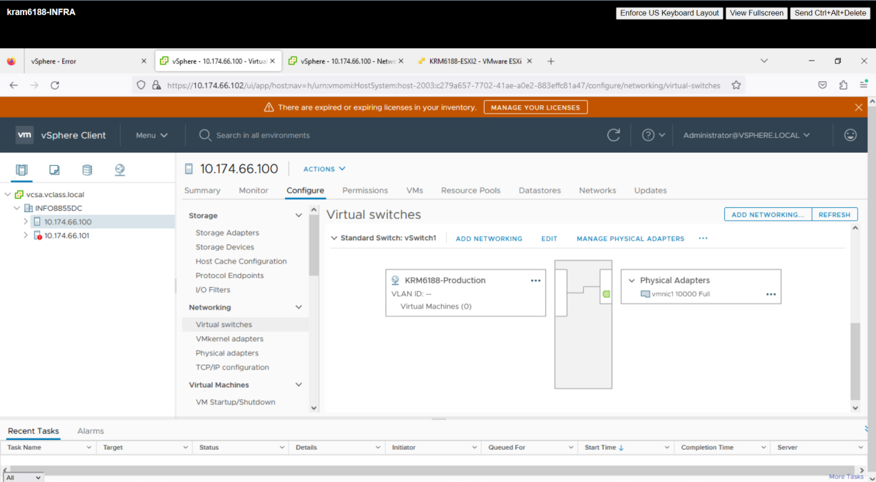  
Fig 1.2 ESXi host created a port group named KRM6188-Production   
  
  
Reflection  
  
In a virtual environment, it is crucial to make sure that all hosts have identical names for Virtual Machine (VM) port groups. If port groups have different names on different hosts, communication between VMs and other network resources may not be possible, leading to issues such as slow performance or connectivity problems.To prevent such problems, network administrators must create the same port group names on all hosts that need to communicate with the same network. This ensures consistent network connectivity for VMs, no matter which host they are running on.Moreover, network administrators need to decide between using a standard switch or a distributed switch. A standard switch is a software-based switch that is part of each ESXi host, and it is easy to set up and requires no additional infrastructure. However, it does not offer advanced features such as centralized management or network monitoring.In contrast, a distributed switch spans multiple ESXi hosts and provides advanced features such as centralized management, monitoring, and configuration. This simplifies network administration by allowing administrators to manage network settings for all hosts from a central location. Additionally, it provides better network performance and scalability than standard switches.In conclusion, ensuring identical names for VM port groups on all hosts is critical for maintaining network connectivity in a virtualized environment. The choice between a standard switch and a distributed switch depends on specific network requirements and the desired level of management and monitoring.

Task 2 – Configure a VM Isolated Network  
  
Observation

On each ESXi host created a port group named KRM6188-Test on a new standard virtual switch using no vmnic1 for uplink on each ESXi host  
  
Screenshots  
  
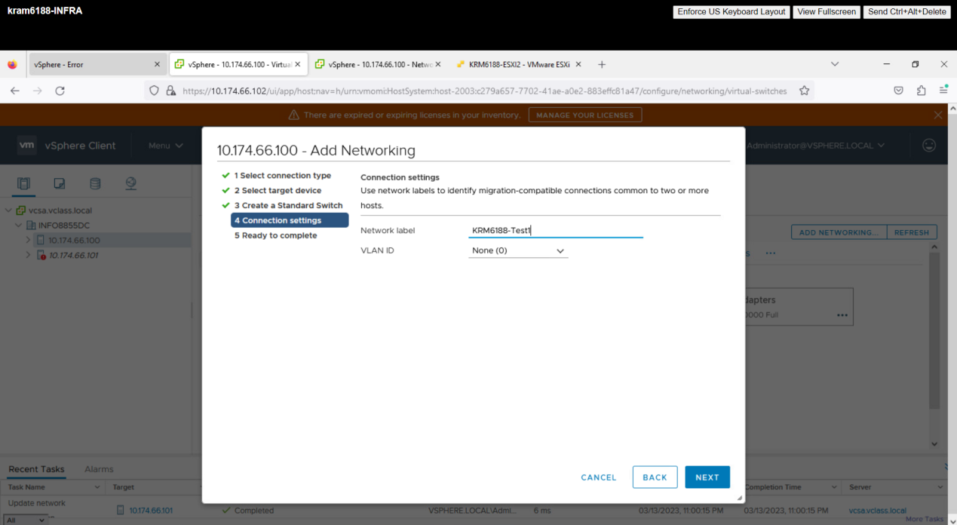  
Fig 2.1 Network is added with no uplink  
  
  
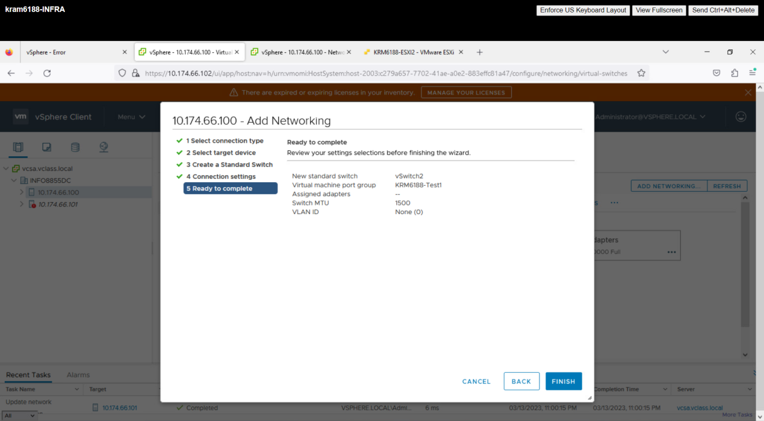  
Fig 2.2 No adapters is selected

* Reflection  
    
    
  Isolated virtual networks offer a robust solution to ensure secure communication in a virtualized setting. By segregating network traffic into separate networks, administrators can guarantee the confidentiality of sensitive data and restrict access to authorized users only.The main advantage of utilizing isolated virtual networks is their ability to establish secure test environments. By deploying isolated networks, administrators can create test environments entirely isolated from the production environment, thus preventing any testing or experimentation from affecting the live environment. This is particularly crucial when testing new software or network configurations that may lead to downtime or other problems if introduced into the production environment.Moreover, isolated virtual networks can also segment traffic within the production environment, enabling organizations to manage data more efficiently. For instance, an organization can establish an isolated network for handling payment processing data, ensuring the confidentiality of this sensitive information and keeping it segregated from other network traffic.  
    
    
    
    
    
    
  Task 3 – Configure a High availability VM Network  
    
  Observation
* On each ESXi host created a port group named KRM6188-Demo on a new standard virtual switch using vmnic2 and vmnic3 as uplinks on each ESXi host.
* Ensured that the uplinks are teamed active-active and use IP hashing for load balancing
* Deleted the virtual switches created during this task once you are finished with the lab  
    
  Screenshots  
    
  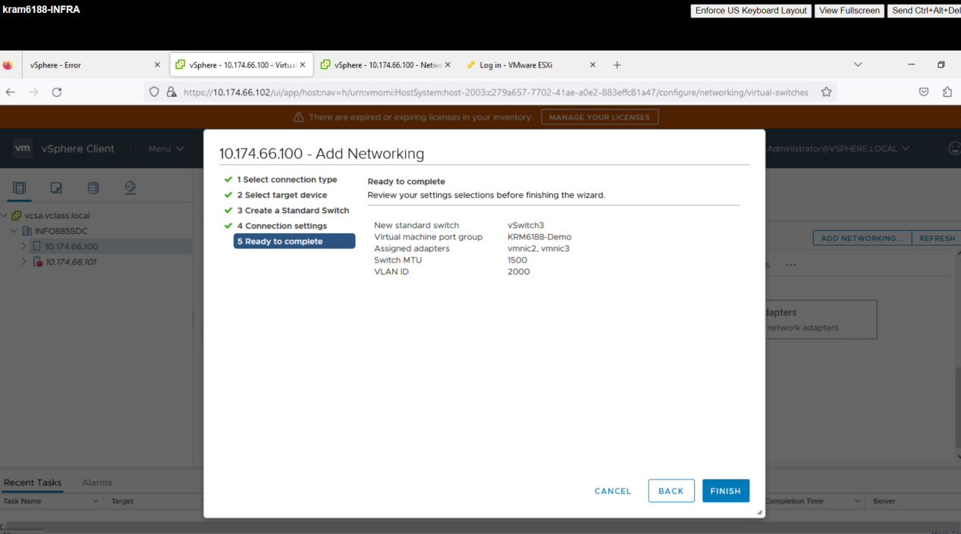  
  Fig 3.1 Created port group with two uplink VMNIC2, VMNIC3   
    
    
  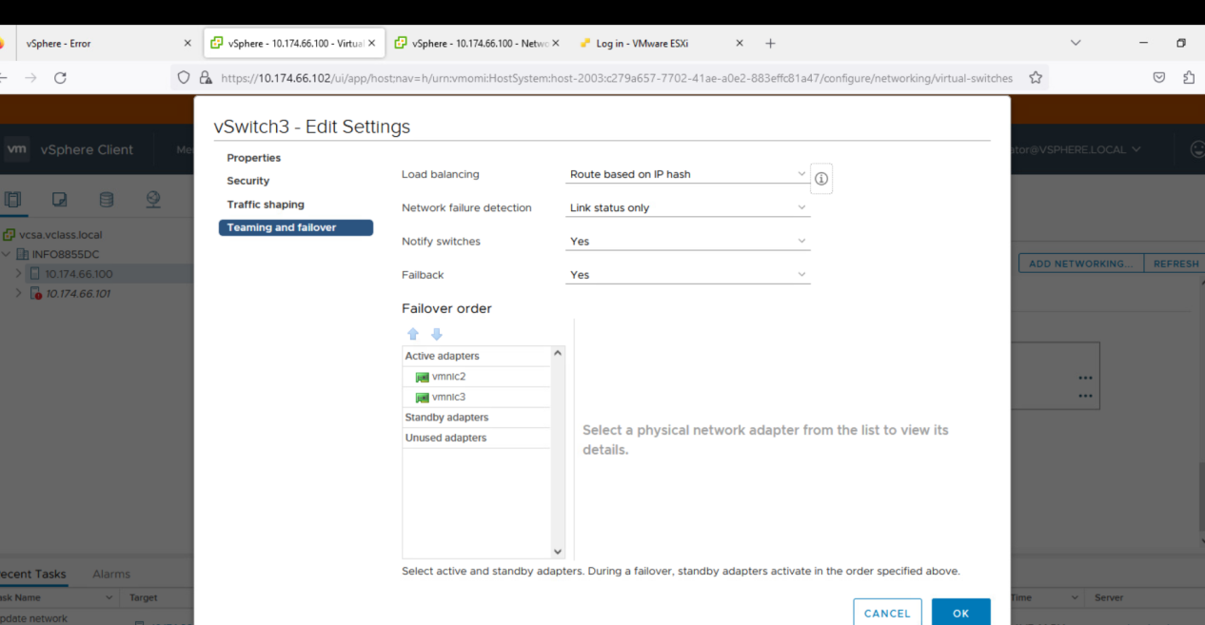  
  Fig 3.2Enabled active-active end route based on IP for load hashing  
    
  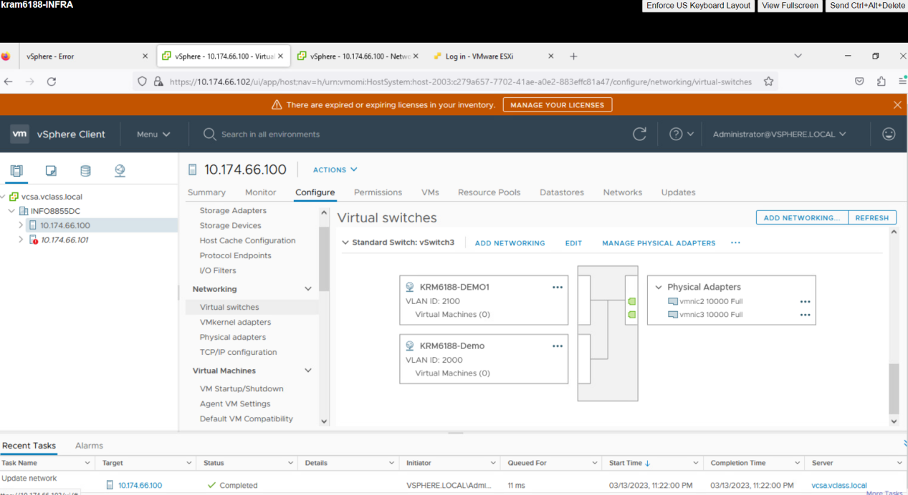

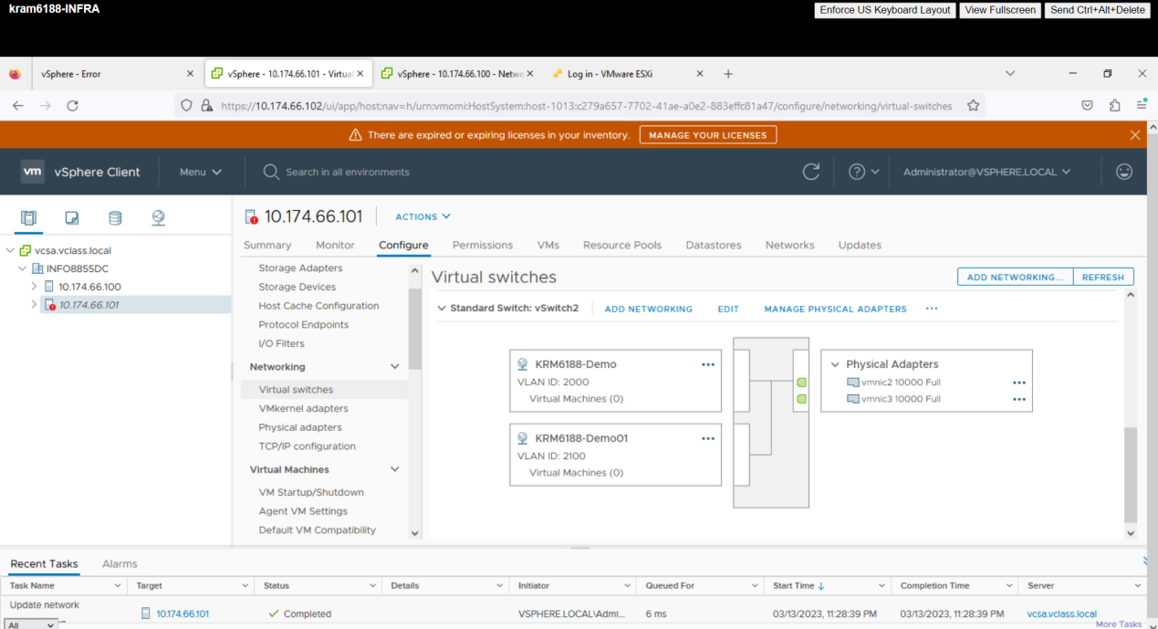  
Fig 3.4 Created port group with two uplink VMNIC2, VMNIC3  
  
  
Reflection  
  
Load balancing is a crucial aspect of network management, especially in virtualized environments, where multiple virtual machines (VMs) may compete for limited resources. Different load balancing techniques can be used to distribute traffic across multiple servers or VMs to optimize performance, improve reliability, and avoid overloading specific resources.Some of the common load balancing techniques include round-robin, least connections, and IP hash. Round-robin distributes traffic in a sequential manner, while least connections assigns new connections to the server with the fewest active connections. IP hashing uses the source IP address of the client to select a server, ensuring that requests from the same client are always directed to the same server.